**Velagapudi Ramakrishna Siddhartha Engineering College**

**CBCS Course**

**Data Visualization Lab**

**Code : 20IT5607**



**Table OF Contents**

**Task – 1** 3

**Task – 2** 6

**Task – 3** 10

**Task – 4** 13

**Task – 5** 16

**Task – 6** 28

**Task – 7** 41

**Task – 8** 50

**Task – 9** 52

**Task – 10** 54

**Task – 11** 57

**Task – 12** 60

**Task – 13** 66

**DATA VISUALIZATION LAB**

# **Task – 1**

**Aim :** Introduction to the Data Visualization

1. **What is Data Visualization ?**
2. It is a Graphical Representation of the Information and Data in

In the form of Visual like charts, Graphs, maps .. etc; To make data

Easier to the Human Brain to understand and pull the insights from the visuals.

1. **Difference between RDBMS, Data Warehouse, Big Data ?**
2. RDMS : It stores the Data in Releationsi.e; Tables and they are

in 2 – Dimensional Data and we can easily manipulate

and calculate the data.

Data Warehouse : it is a multi dimensional Database and it

Applies the analysis, analytics on huge amount of data

At a time from all sources i.e; database, nosql;

Big Data : The name it self says that it handles and bundles of the

Trillions of data analyzes with volume, velocity, variety

Of characteristics and many more.

1. **Examples for RDMS, Data Warehousing, Big data ?**
2. RDMS : sql, mysql, MongoDB, microsoftsql, oracle DB.

Data Warehousing :a data warehouse might combine customer information from an organization's point-of-sale systems, its mailing lists, website, and comment cards

Big Data : Hadoop, banking and financial services.

1. **Examples For Data Visualization ?**
2. Examples are tableau, Power Bi, MS Bi, charts, graphs, maps,

Histograms, scatter plots, box plots, violin plots..

1. **Difference Between Reporting Service Tools And Data Visualization Tools ?**
2. Reporting Service Tools : it’s kind of making an story telling

From data in visuals like charts, graphs, tables all together

Data Visualization Tools : after cleaning and querying the data

the final step is to represent in the visuals using data visualize tools i.e; charts, visualizations panel;

1. **Difference between Different Types of Charts ?**
2. There are 2 mainly charts are used they are :

Bar charts : represents the data is rectangles , squares and in

Bars.

Pie charts : represents the data in circles with high % and low %

And some others by highlighting the required

Parameters.

1. **What is a Dashboard ?**
2. A dashboard is a collection of visuals and reports all together

At a time is called dashboard

1. **What are Different Sources For any Data Visualization Tools ?**
2. Tableau, Microsoft Power Bi, excel, Qlick View, Data Wrapper,

Github, Amazon Web Services,

# **Task – 2**

**Aim :** Install the microsoft power bi software

**Procedure :**

1. Go to the website [https://powerbi.microsoft.com/en- us/downloads/](https://powerbi.microsoft.com/en-%20us/downloads/)
2. Navigate to the products panel and click on the Power Bi Desktop

Option.

1. Now click on the “ see download and language options “ the scroll down to the webp page and select the required language and click on the download option.
2. Next select the option Powerbidesktop setup.exe file and click on the “ Next option “
3. After download the file then run the file.

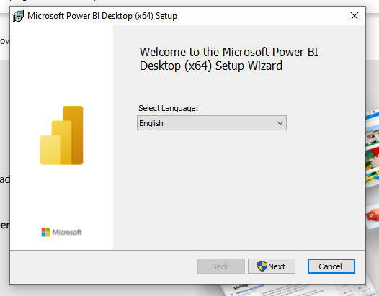

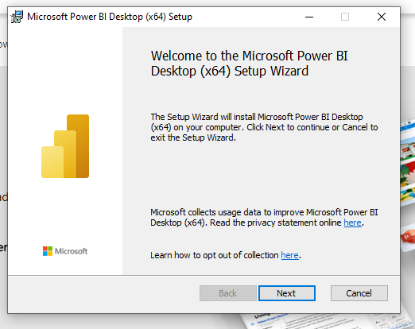

1. Selec t the destination drive and folder to download the software

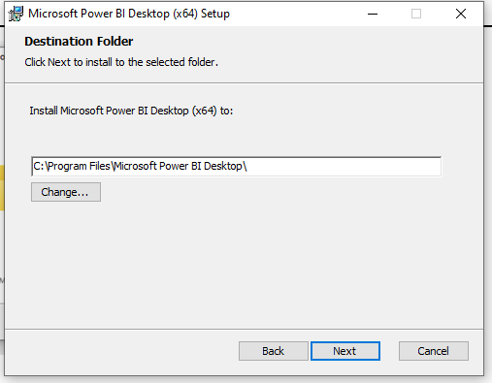

1. After then you can see the downloading the files

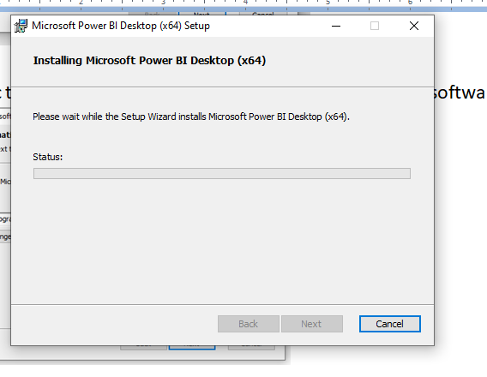

1. After downloading the files you will see the final option

That option represents the successfully downloaded.

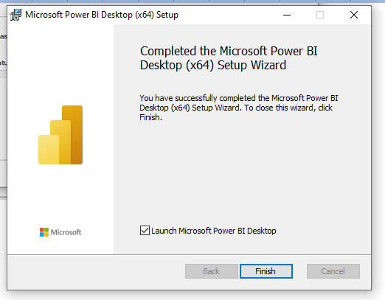

1. The final view of the power bi software is below one.

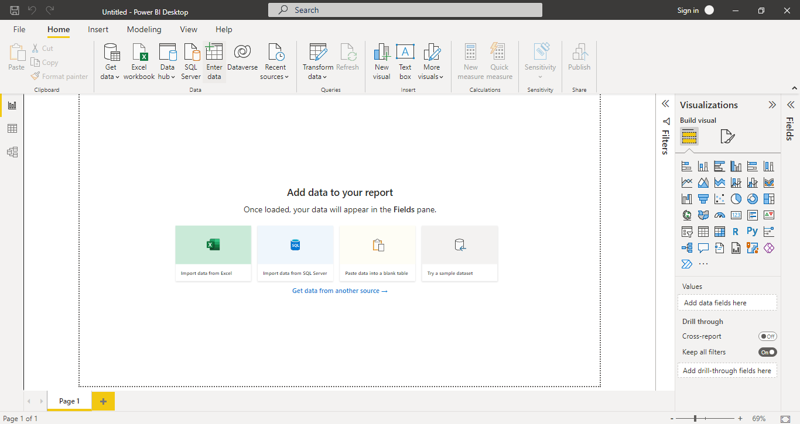

# **Task – 3**

**Aim :** Features of the Power Bi

**Procedure :**

There are many features exists in the Microsoft power bi but some of the most recently used features are listed below ones’s

1. **Data Connection :**

Microsoft has developed data source connections with a huge list of sources like SQL, Azure, Excel, Text, CSV, PDF, Cloud, on-premises data. It doesn’t matter where the data is and what format it is; we will get a detailed view of the data.

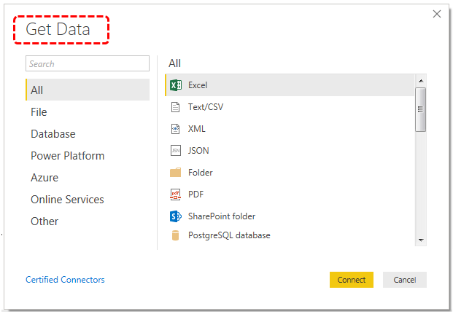

1. **Data Relationships :**

In Power, if you have data in multiple columns, then we can define the relationship between those tables based on at least one matching column from either table. Below is the screenshot of creating relationships between tables.

We call this process as “Data Modelling” in Power BI.

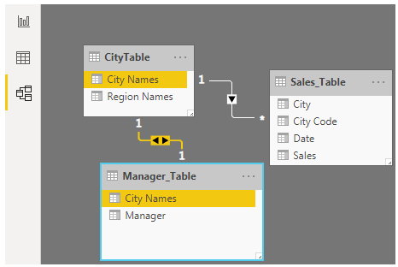

1. **Power Query and Query Piviot Access :**

It is also known as query processing for the data in the power Bi tool and it plays an major role in modelling the data

In Power BI, we can edit the data by using “Power Query in Excel

” and “Power Pivot.” These are all different components of Power BI, which helps the user to alter the data in such a way it fits their needs. Power BI Queryis used to data transformation and manipulation tools, and Power Pivot is a memory tool to model the data.

1. **Custom Visualizations :**

Power BI comes with a lot of built-in visuals to build dashboards and reports. Apart from these built-in visuals, users are allowed to download the custom visuals from market places as per their requirement.

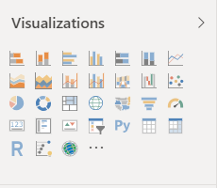

**Result :** Sucessfully Completed the all Tasks.

# **Task – 4**

**Aim :** Import a flat file i.e; excel or any csv files and visualize them.

**Procedure :**

1. Open power bi and click on the Get data button and choose the import data from the excel.

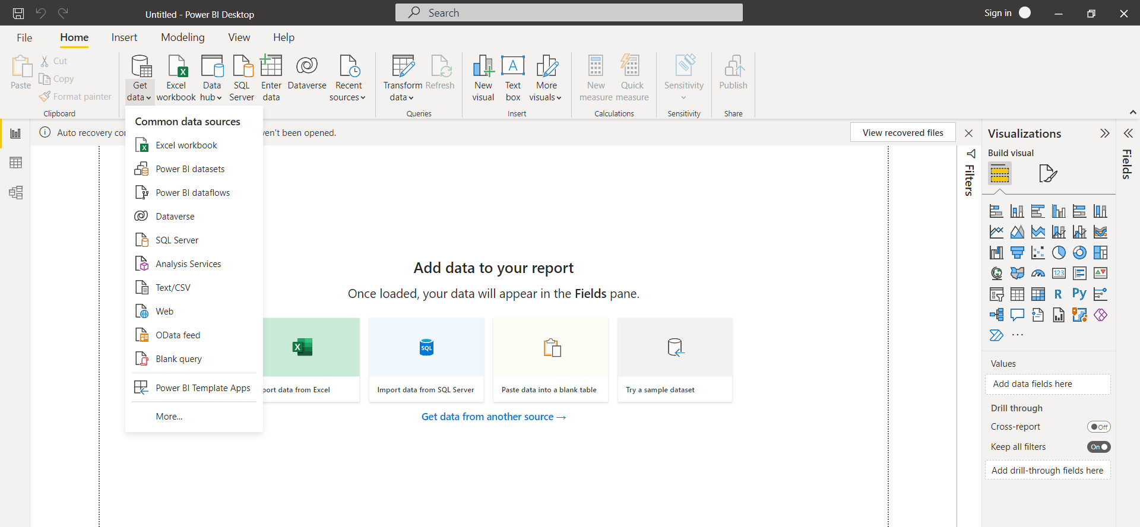

1. And then load the data into an power bi.

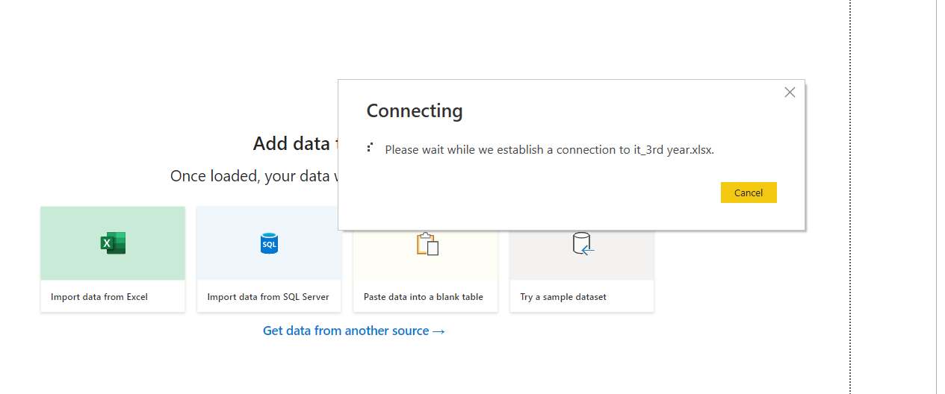

Select the any one the tables in the excel file in which you have loaded .

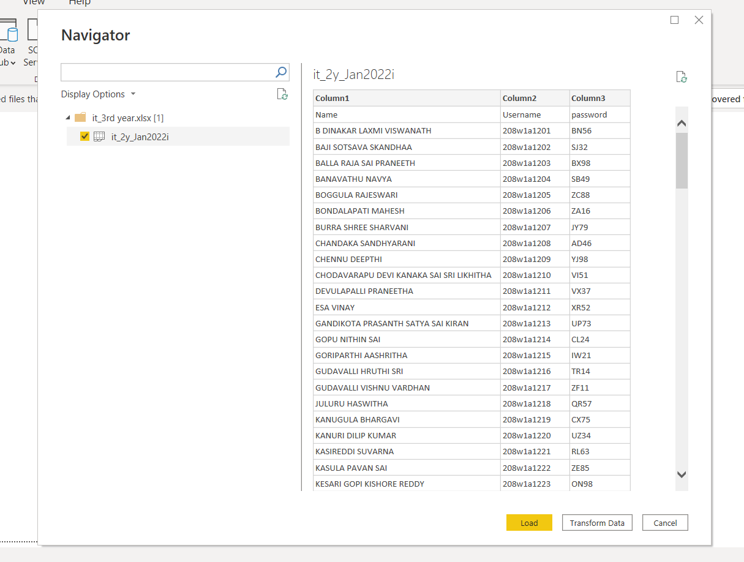

Now click the Transform data then do some heading changes in the data then apply any other modifications if you like according to your transforming the data .

Then you can see any the percentage of the errors and correction in eah and every column of the graph.

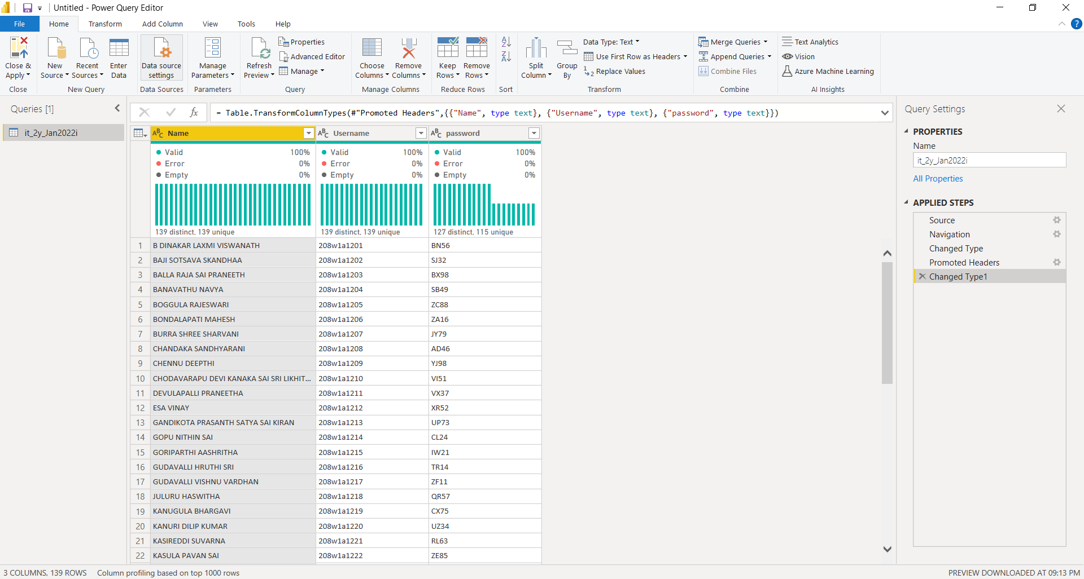

1. Now then visualize the data with different types of visuals like charts, graphs, plots.. … etc;

**Output :**

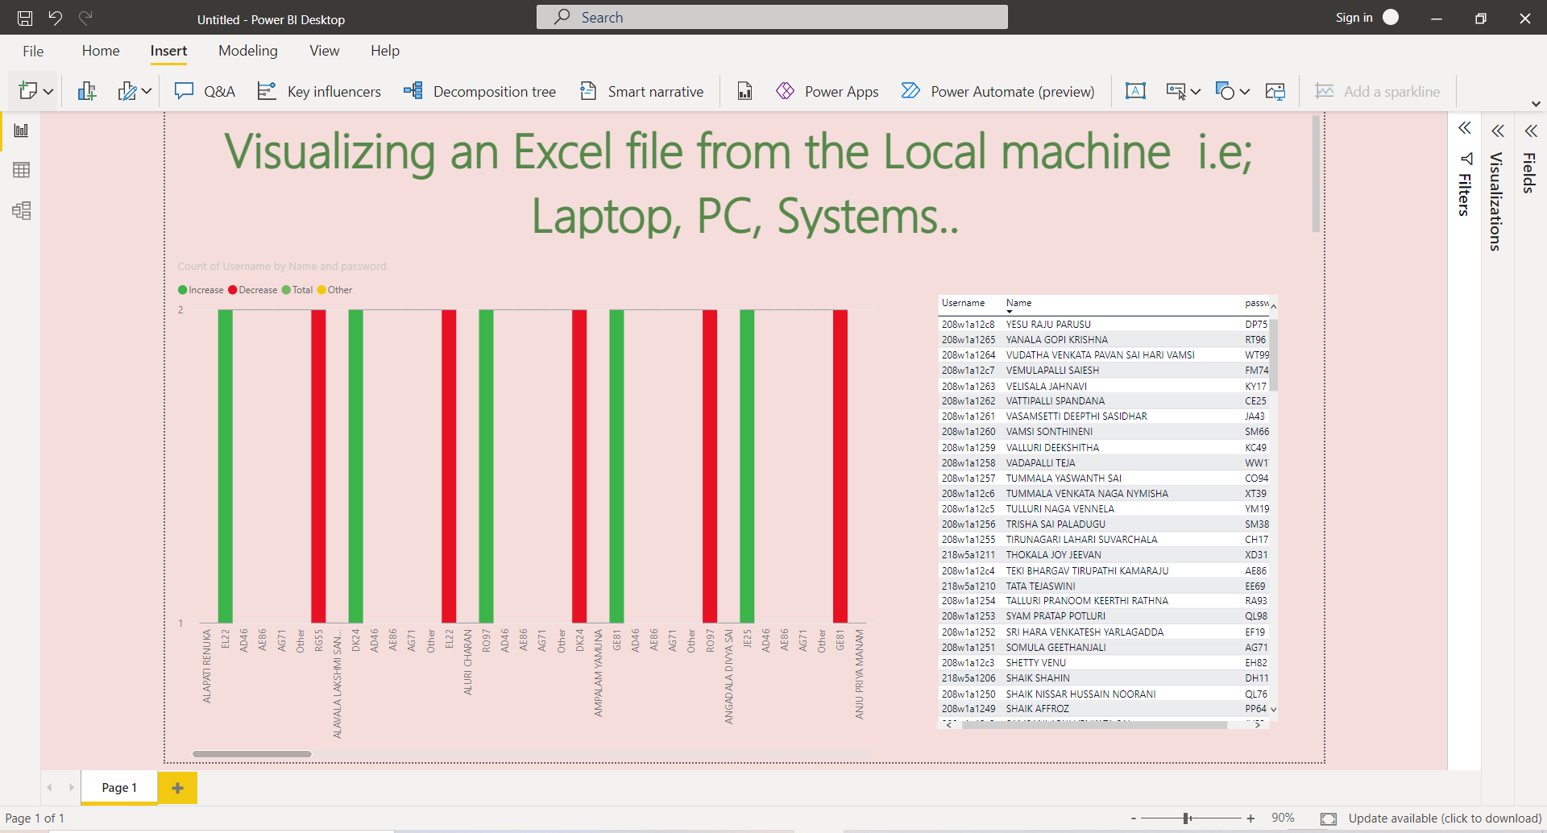

**Result :** Sucessfully completed the Aim.

# **Task – 5**

**Aim** : Get any data From the internet web and visualize in the power bi

**Procedure :**

1. Click on the get data button and then click on the web and paste

The url which is copied and click on to load the data

1. Then clean the data and do some changes by using the power BI

Query editor

1. The next step is Once you complete all the changes then click on save and load option
2. Finally, by using colums generate the different types of visuals in the report or in dashboard

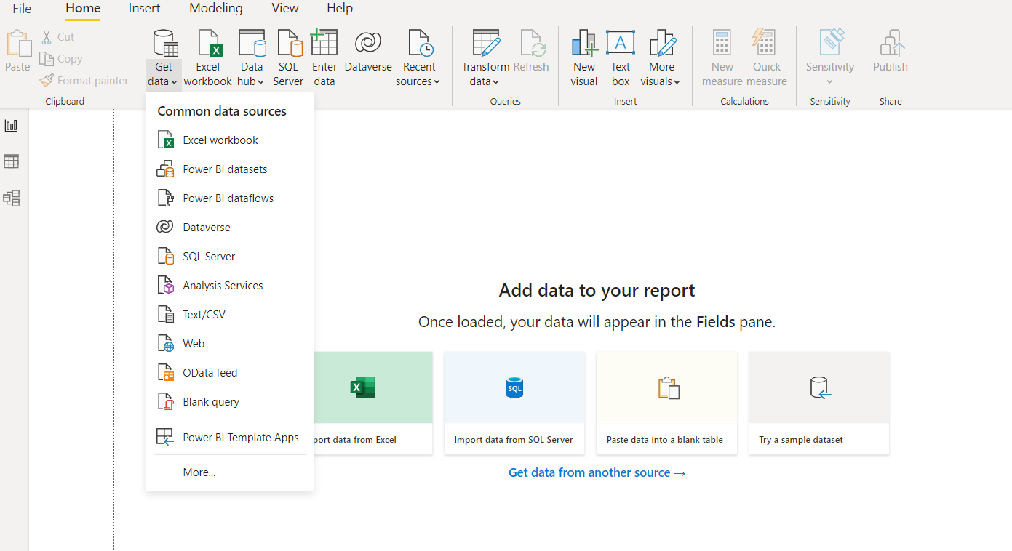

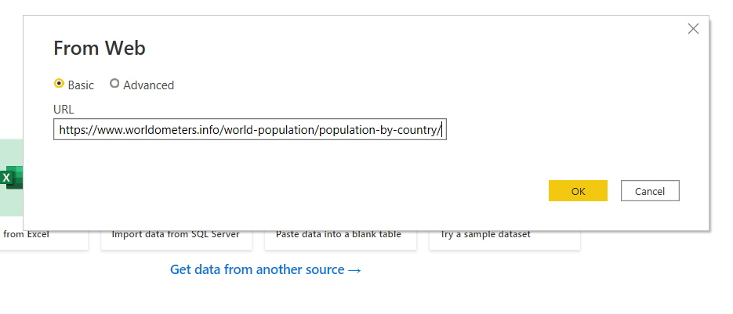

1. Choose the any one of the table and click on the transform button then you can see the query editor

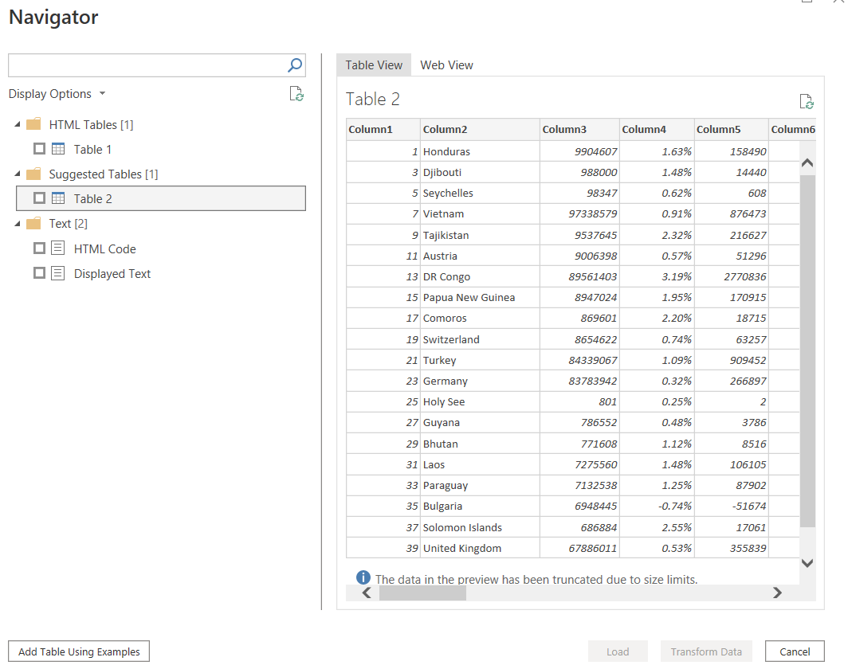

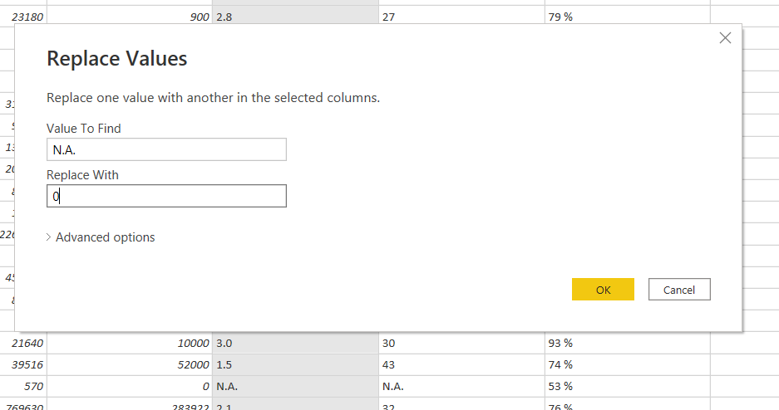

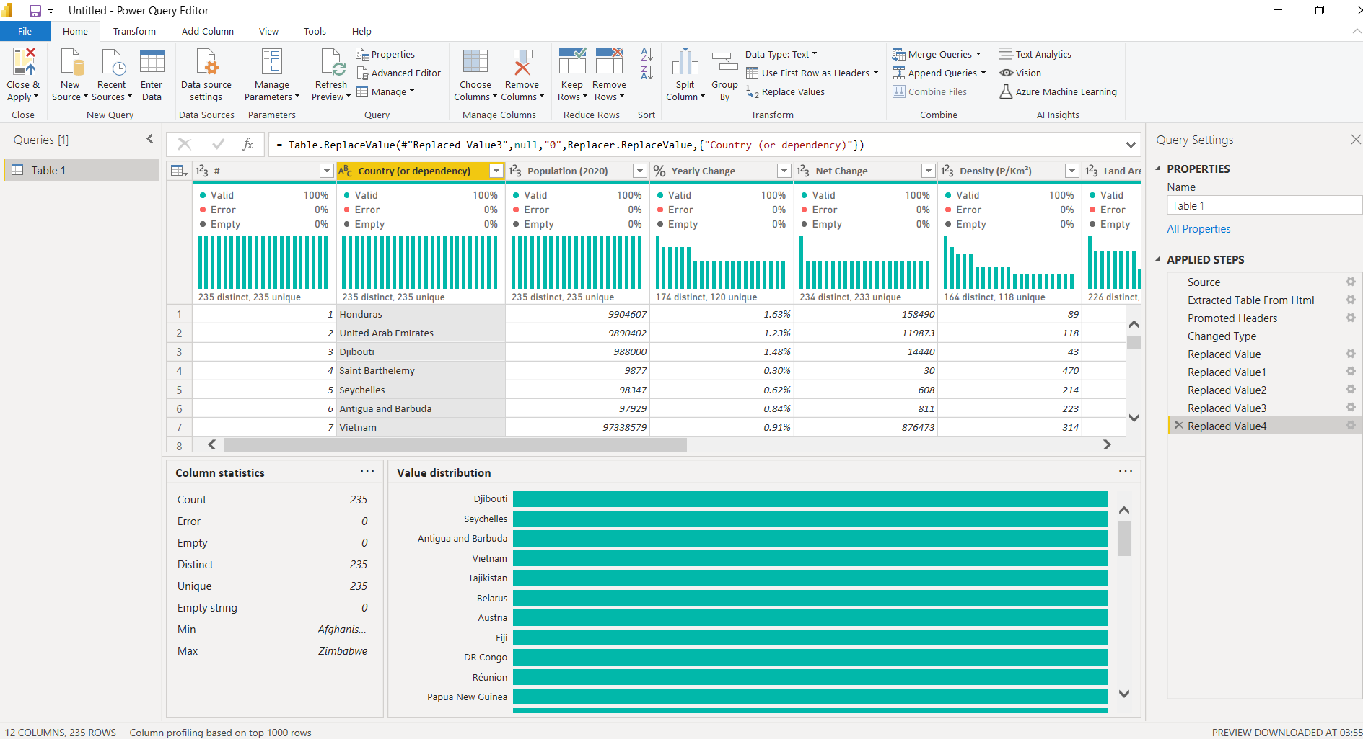

**Output :**

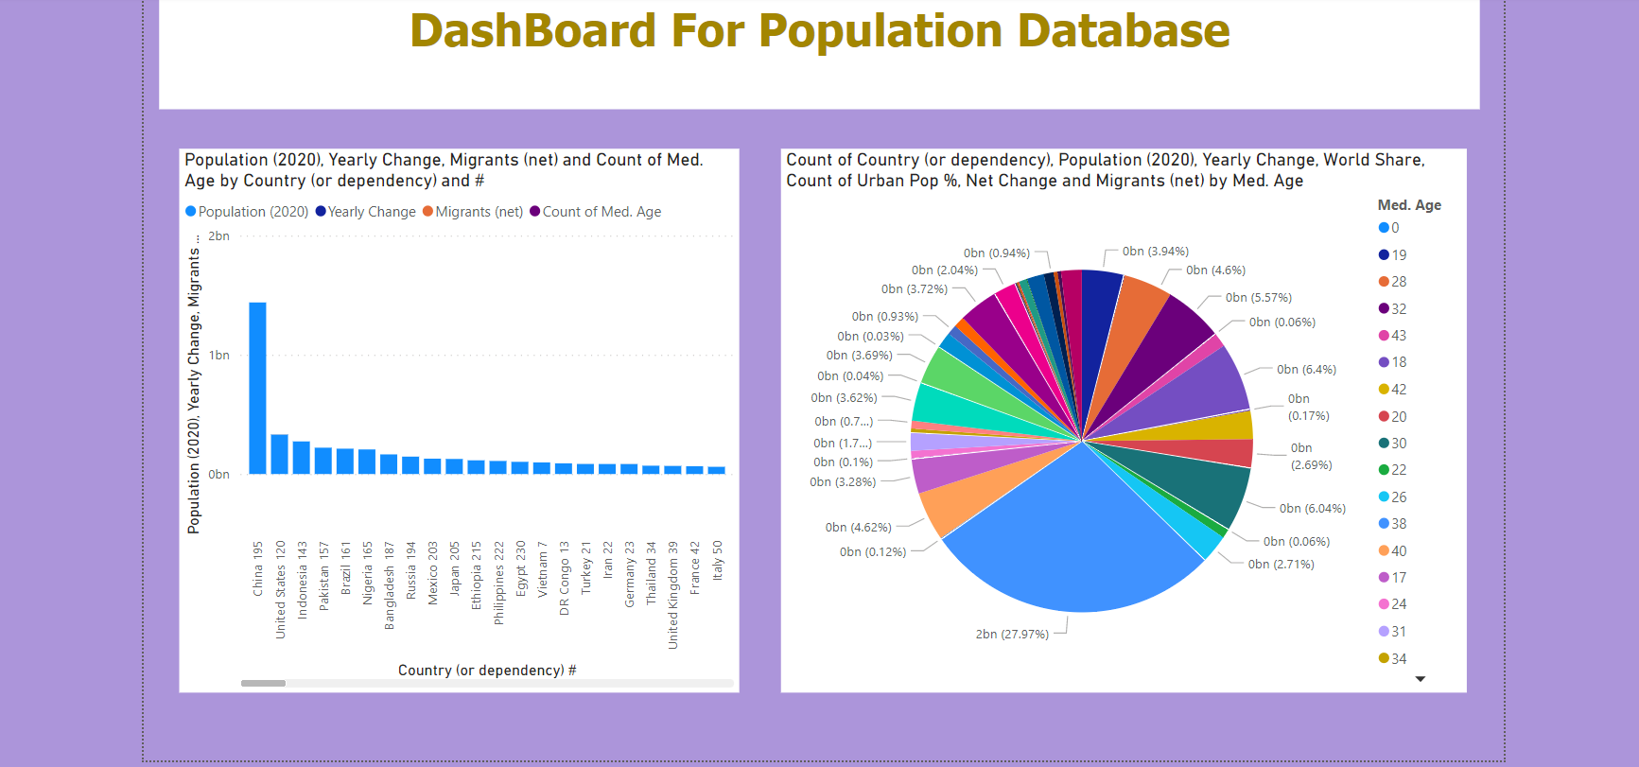

**Aim :** Take any ODATA url from web any analyze and visual in the

Power BI dashboard or report

**Procedure :**

1. Now, go to the internet and search for NORTH wind ODATA wind dataset and copy the url
2. Open the power Bi desktop and click on the get data from the ODATA feed and paste the copied url and then click on the Load data .
3. Now visualize the data in different types of charts.

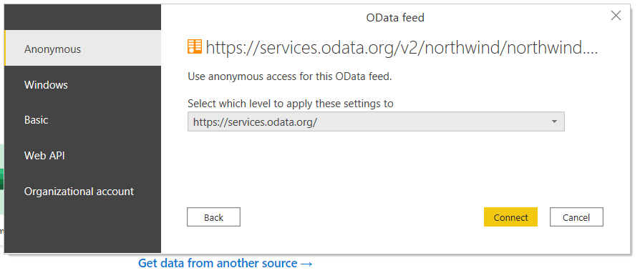

1. Load the data and display in the dashboard

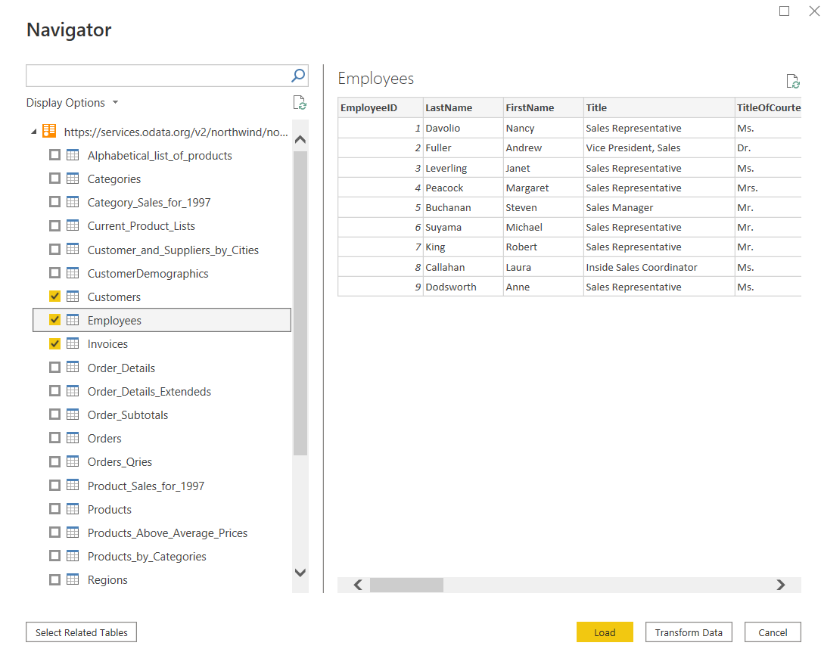

1. Replace the empty cell with the 0 so that it is easy to visualize the column in that table

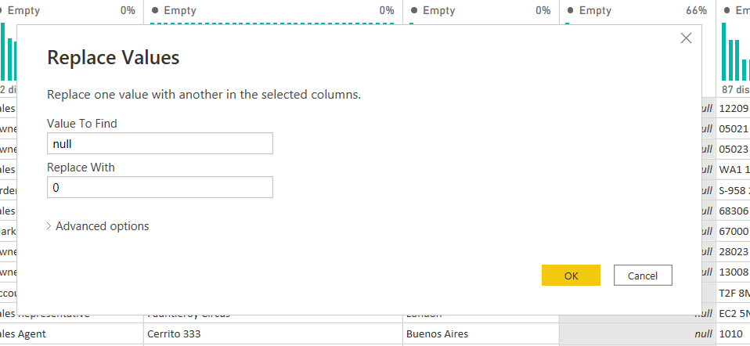

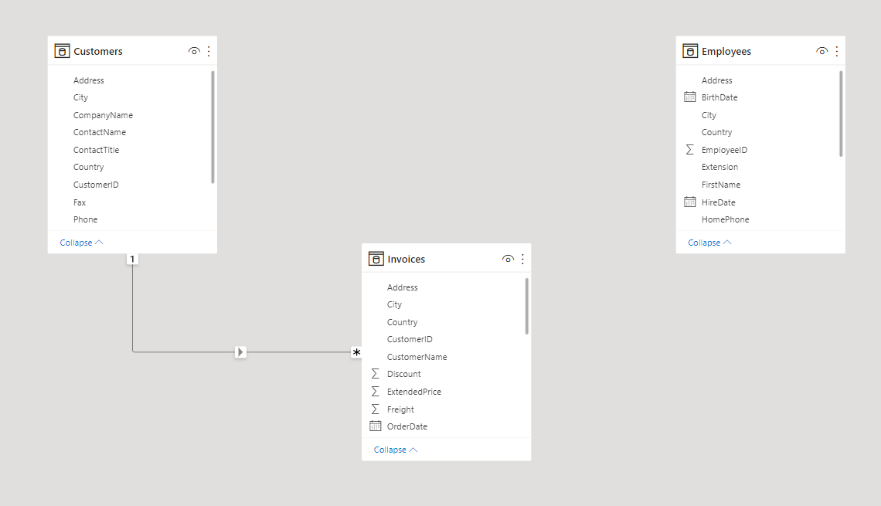

***Output :***

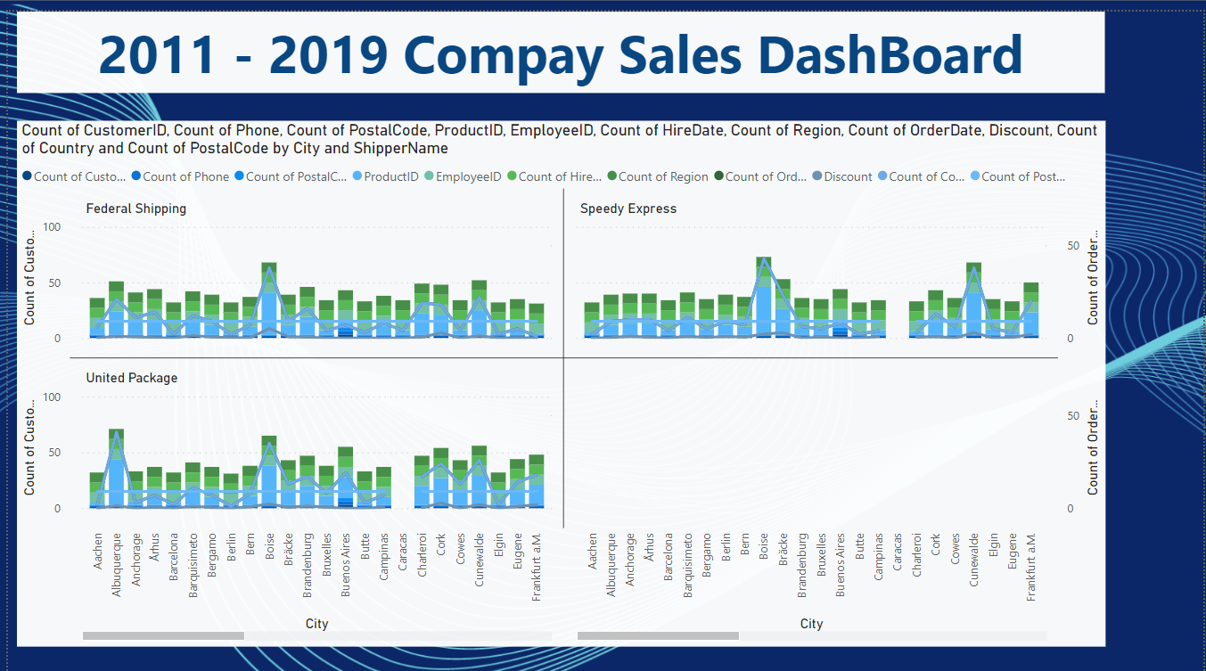

**Aim :** get the data from IMF world database and generate the country

Report and copy the url and visualize the data

**Procedure :**

1. First go to the Imf world database and select the Year.
2. click on the first available link and in that site under download.
3. click on All countries ,select All and click on continue.
4. select subject as GDP current prices by US dollars and click and continue.
5. click on prepare Report and copy the URL.
6. open powerbi click on get data and select web and double click on the web connector and paste the URL.
7. in web view select the required table and click on edit,it will opens query editor.

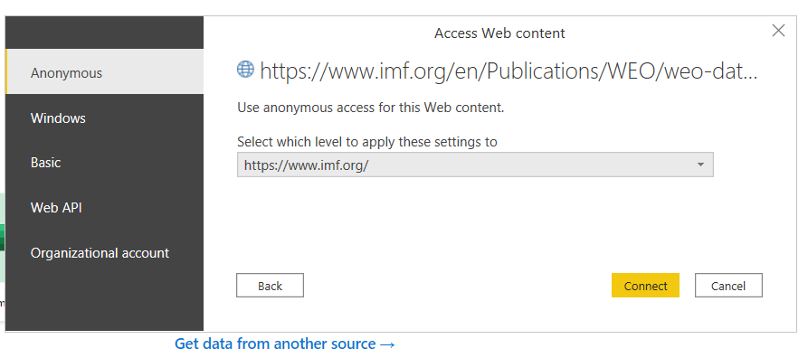

1. Click on the Transform data so that you can edit many thing on the extracted data from the internet.

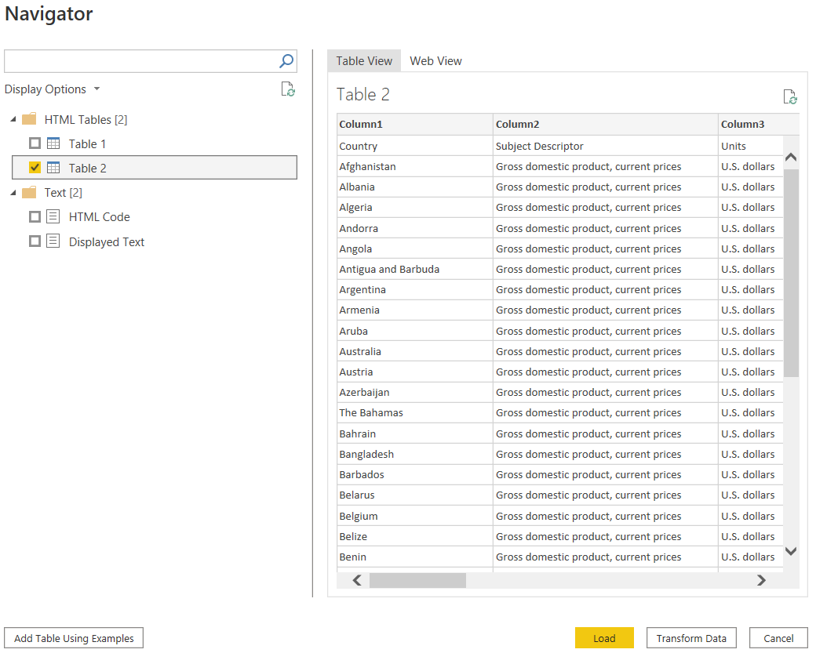

1. Remove unwanted rows in home tab select reduce rows and then remove rowsand then select remove top rows and select number of rows as 1 and click on ok.
2. To take the first row as a header click on transform tb and select use first row as header.
3. In home tab select manage columns,then select remove columns and then selectremove columns which will remove the empty columns.

**Output :**

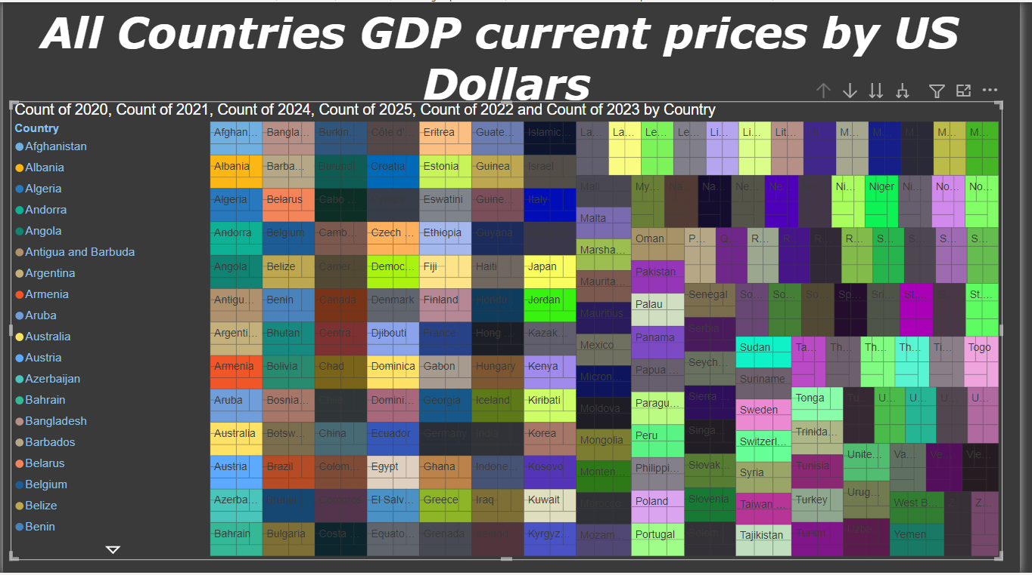

**Aim :**  Download any xml data file and Load in power Bi and display in

Dash board

**Procedure :**

1. connect to the .xml and click on edit to open the query editor.
2. it will display first level and for the below levels it displays as table.
3. click on "expand" <> button for every table to get all the levels complete data.
4. click on close and apply and check the data.

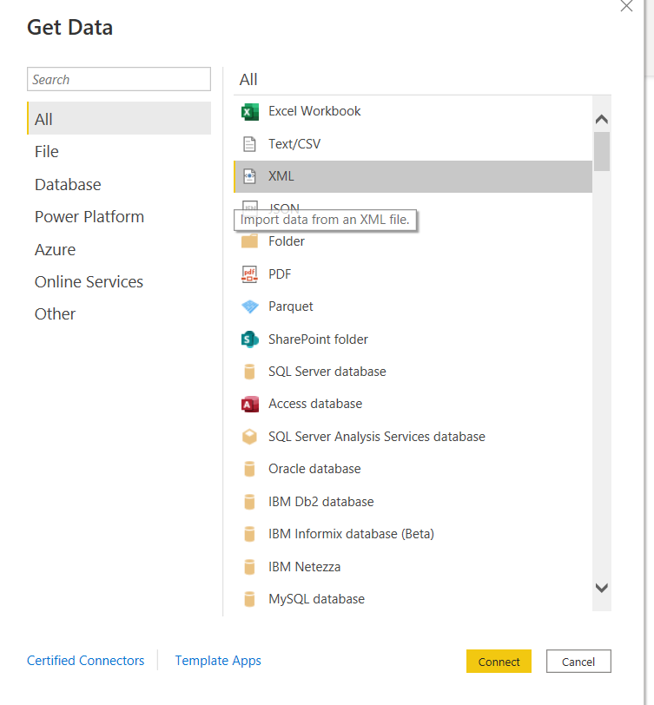

1. Now click on the Load data and then draw an hierarchy if there are more than 2 tables.
2. Finally fill your dashboard with the visuals.

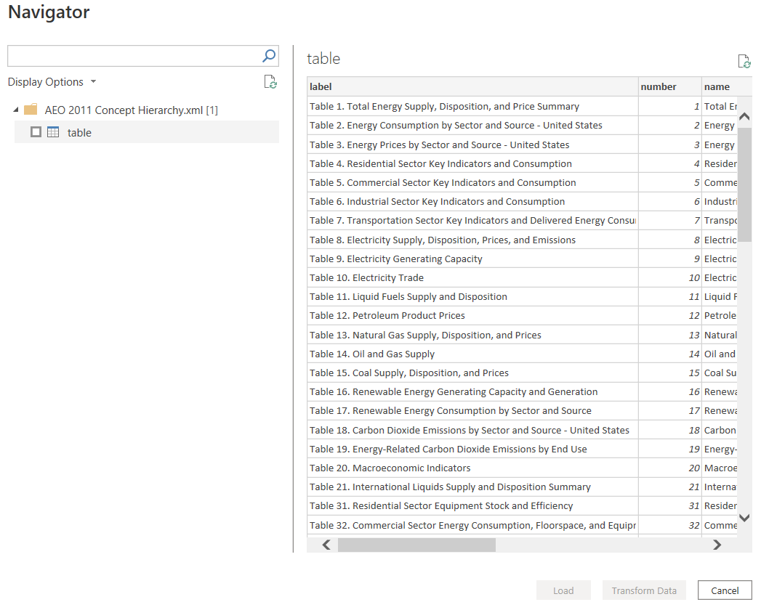

**Output :**

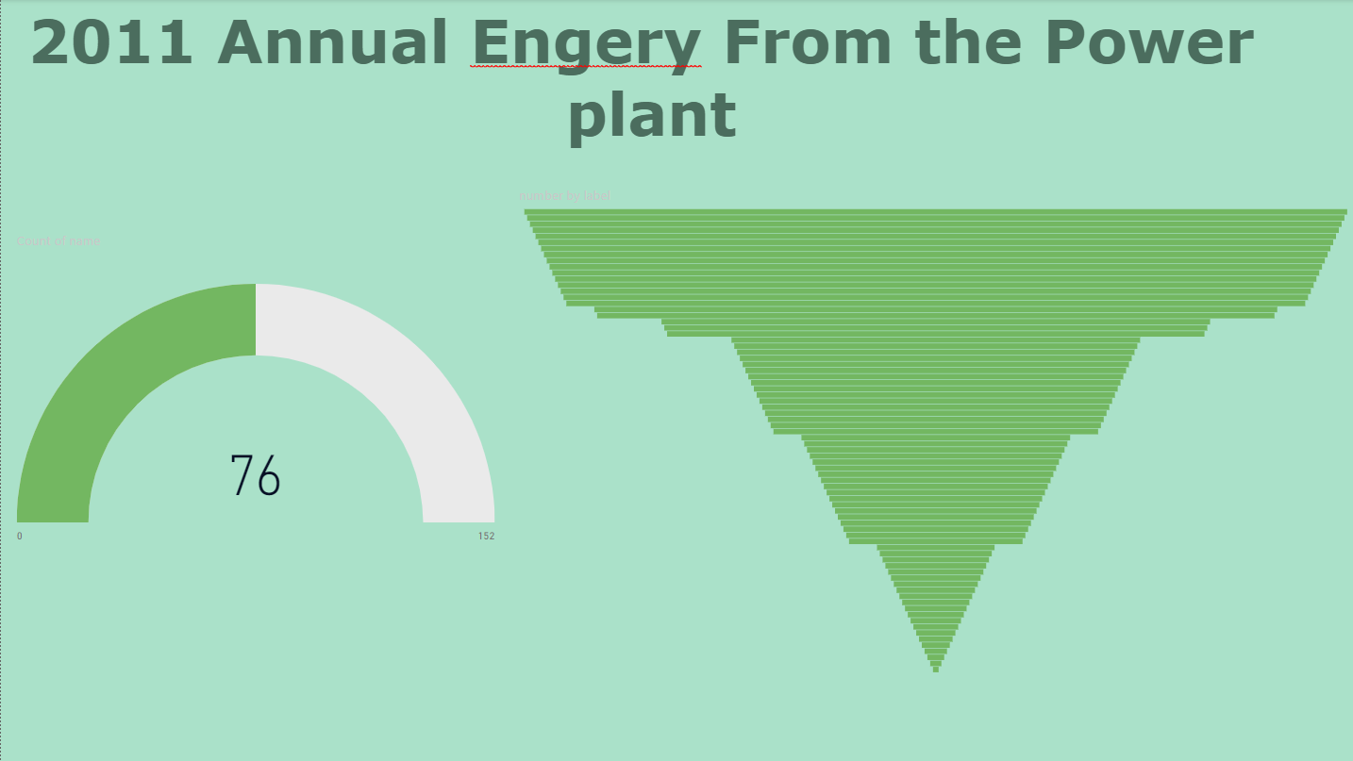

# **Task – 6**

**Aim :** Apply Round, RoundUp, RoundDown, Even, Odd, Sign functions

On any dataset and visualize it.

**Procedure :**

1. First step is to take any dataset based on your domain and dump into Power BI.
2. Open the Power BI and select the data from the excel workbook. And load into the power bi.

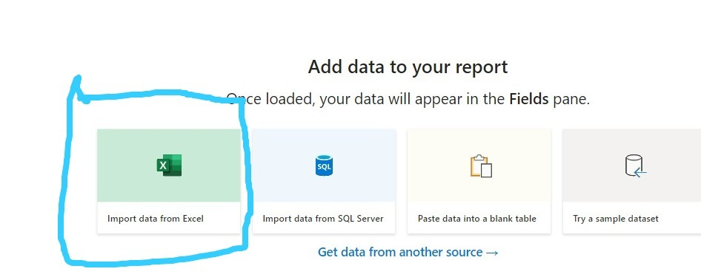

1. After loading the data in power bi and select the relations or tables based on your requirements and see the preview of the tables which you have selected and then click on Transform the data to Do some modifications on the Data.
2. After clicking on the transforming the data the next and imidate step is to remove the unwanted and unnecessary columns in the dataset.
3. After removing the columns or attributes now create 6 duplicate columns of the saving account column.

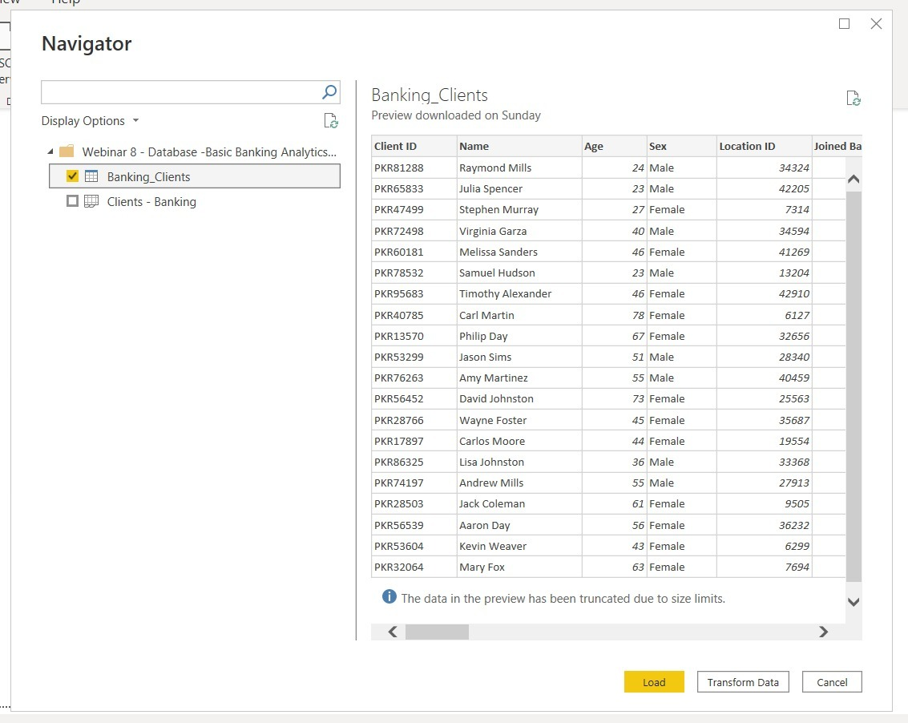

1. Now change the duplicate column names to the odd, even, sign, round, roundup, roundown names
2. Now navigate to the transform and dropdown the information button and then select the is odd option then the savings account column.

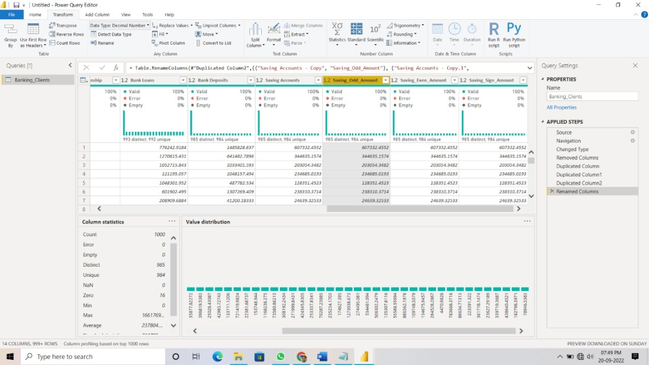

1. Repeat the same process for the ODD, Even, Sign numbers for the savings account.
2. And the final output for this columns will be down below one.

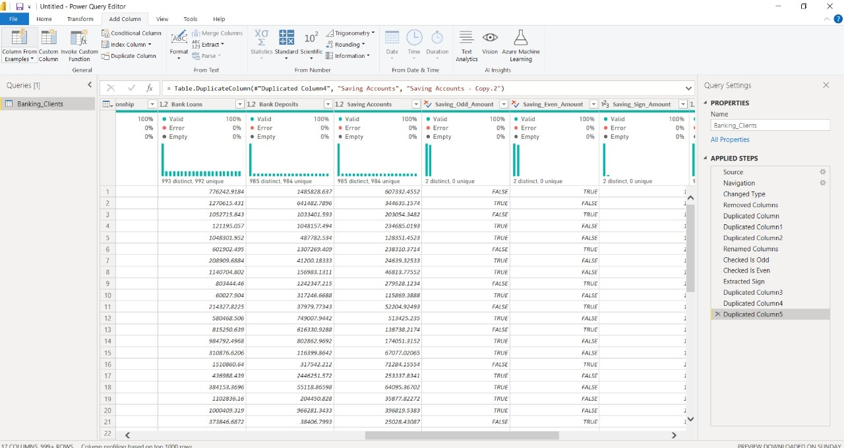

1. Now navigate to the ADD Columns and use the “round” DropDown and use this dropdown on the saving account.

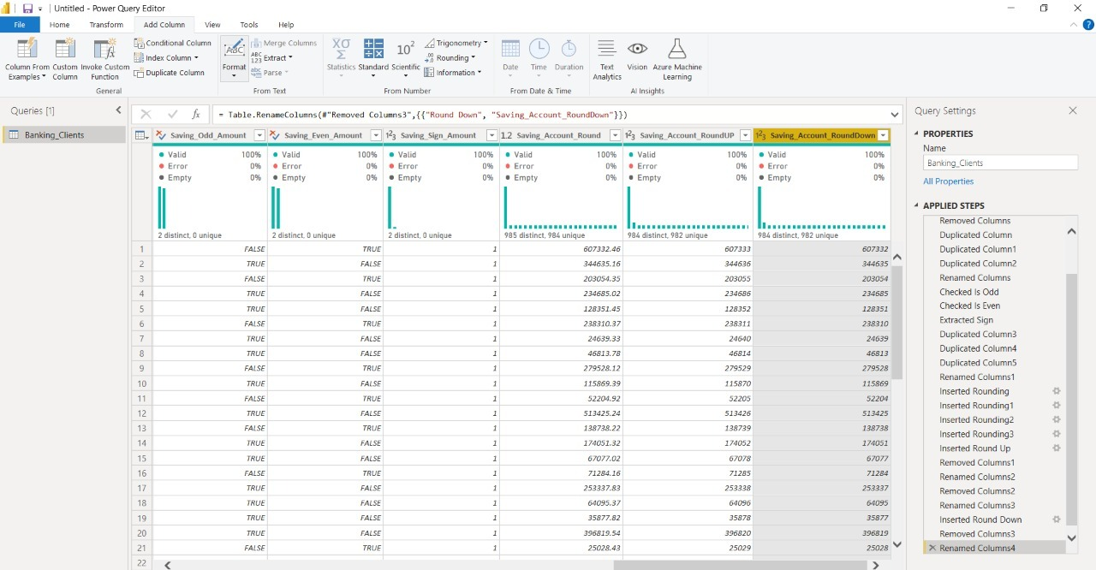

1. For calculating the round value in a column it will ask the precsion of the decimals and see the below pic

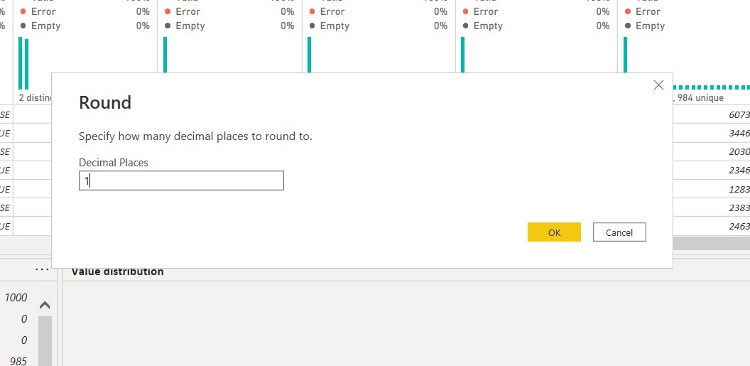

1. The final output values of the column will be like in below pic is calcaulated for all functions like round, roundup, rounddown also.

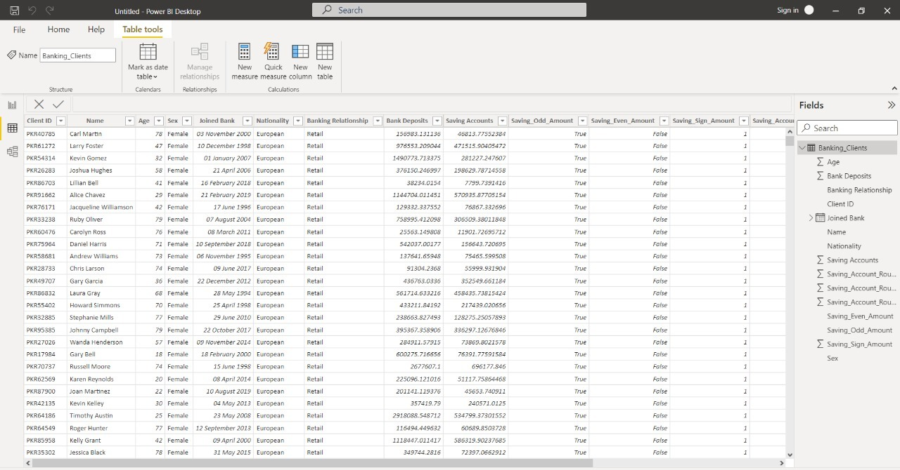

**Output :**

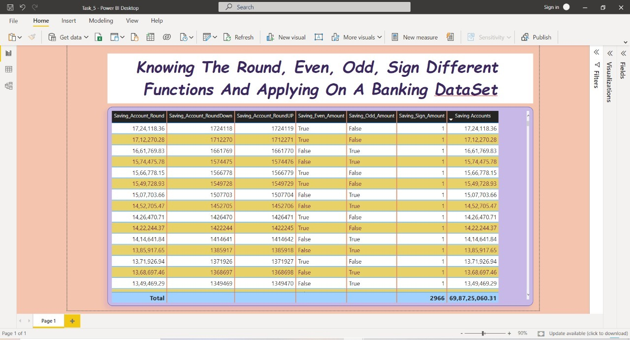

**Aim :** Generation of Dates based on present date and then add a index

Column to it and visualize the data.

**Procedure :**

1. Take any bank dataset and then load into the power bi and then click on Transform data to do some modifications.

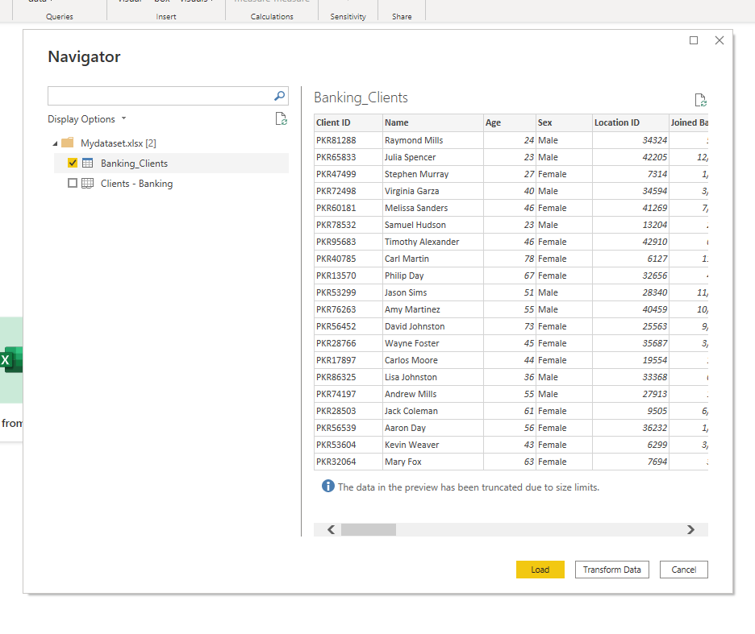

1. After loading the file in to query editor the next step is to remove the unnecessary colums or attributes so that our task to execute and easy to analyze the data.

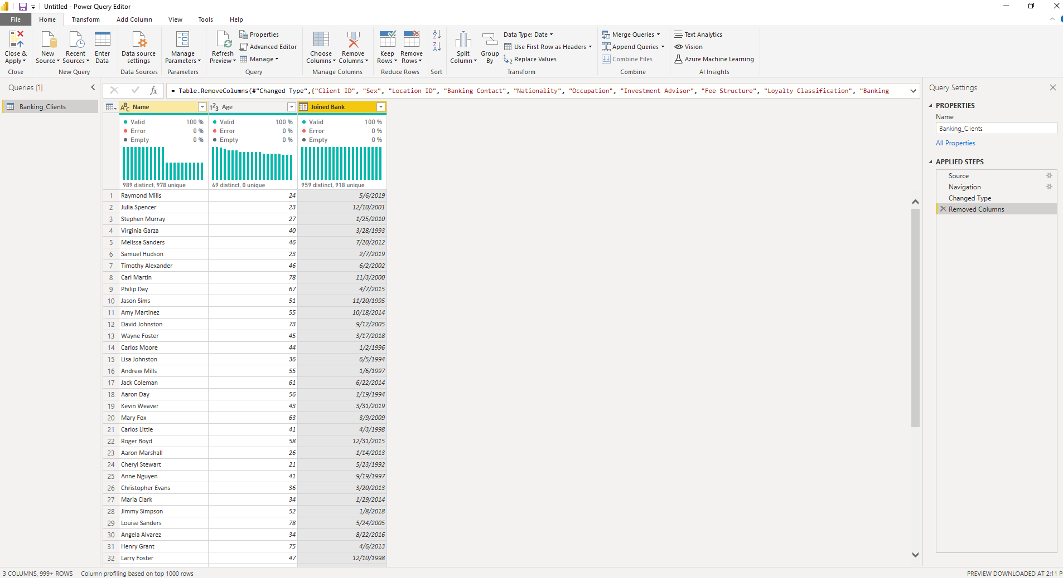

1. Now, navigate to the ADD Column there you can see the how to add a custom column and click on it.

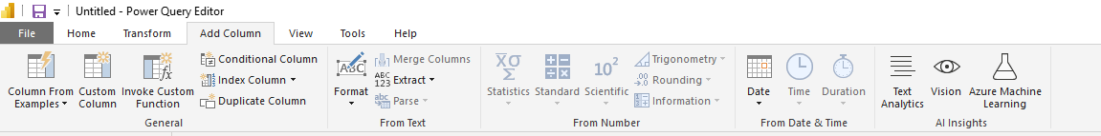

1. Now, write a query to get the list o dats which are subtracted from the joined dates. And then click on OK.

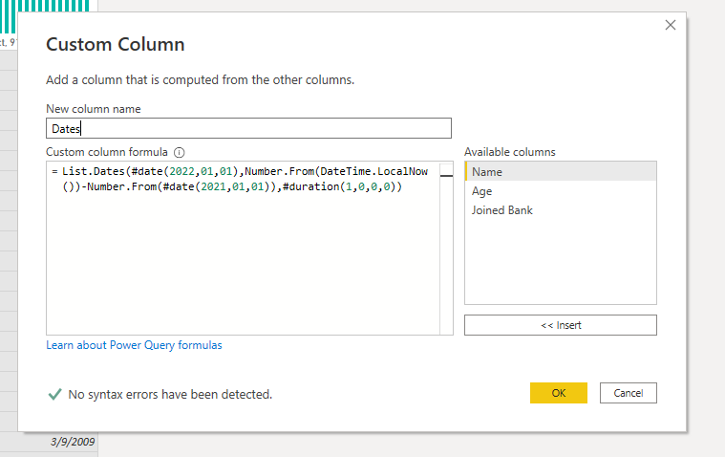

1. After clicking the ok, see at the top left in the column header in which you have added newly and click on the expanding rows then the data will be converted to table.

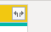

1. Navigate to the add column and click on the add a condoitional column option now you can apply the condition on columns and fill the required fields to get an expected output data in the new column.

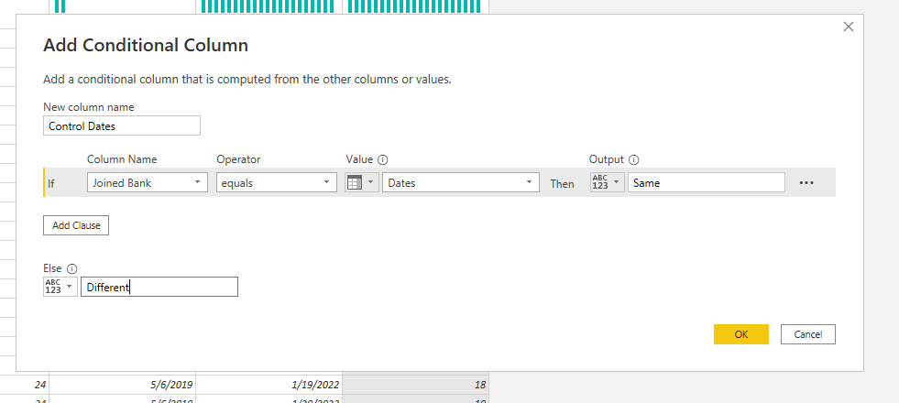

1. After modifying the all data and applying the conditions difference adding new columns the new modified data will like the below one.

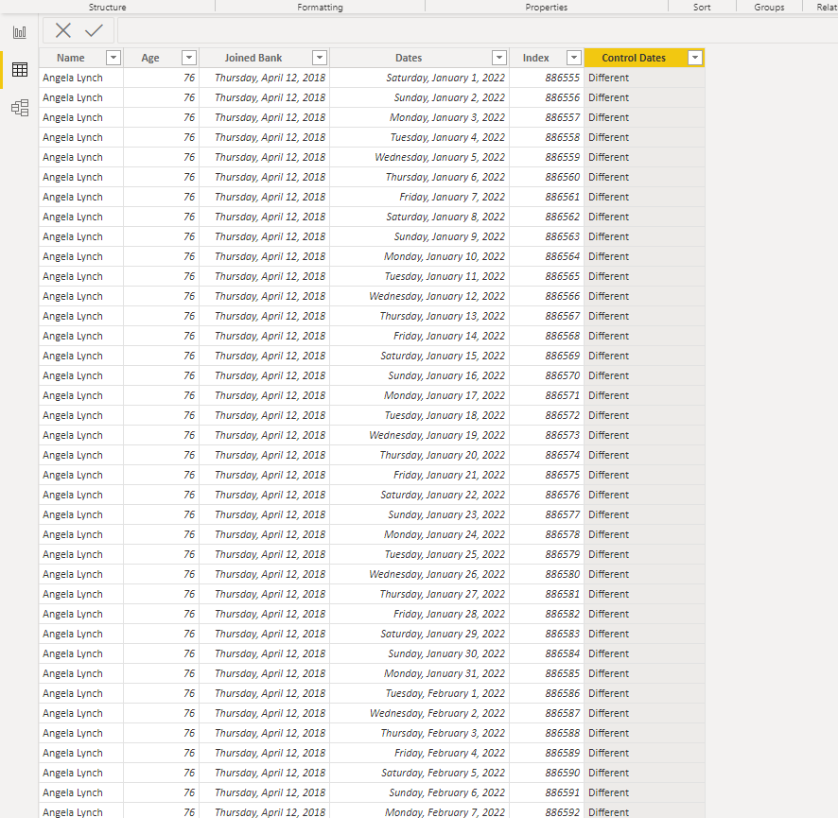

**Output :**

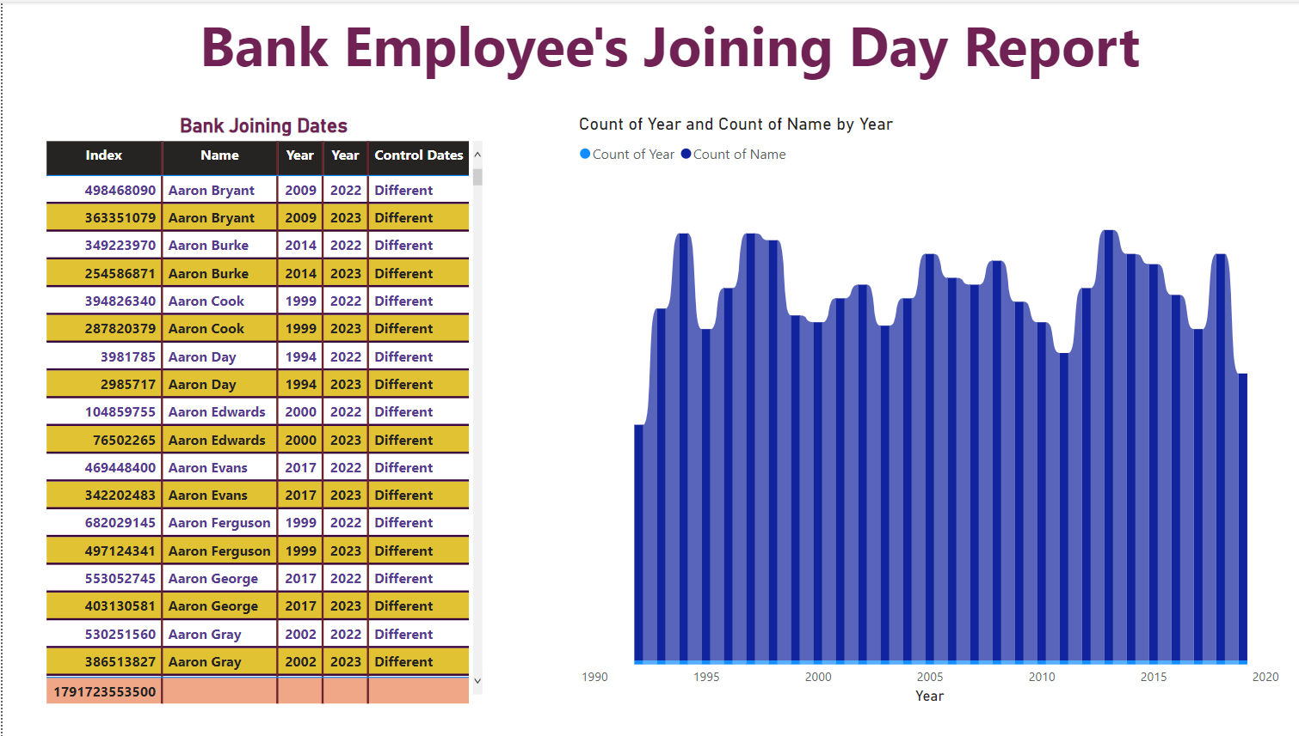

**Aim :** Load any Data and then classify Data by condition column.

**Procedure :**

1. First Load the dataset into the Power bi and click on transform to remove the unwanted attributes or columns in dataset.

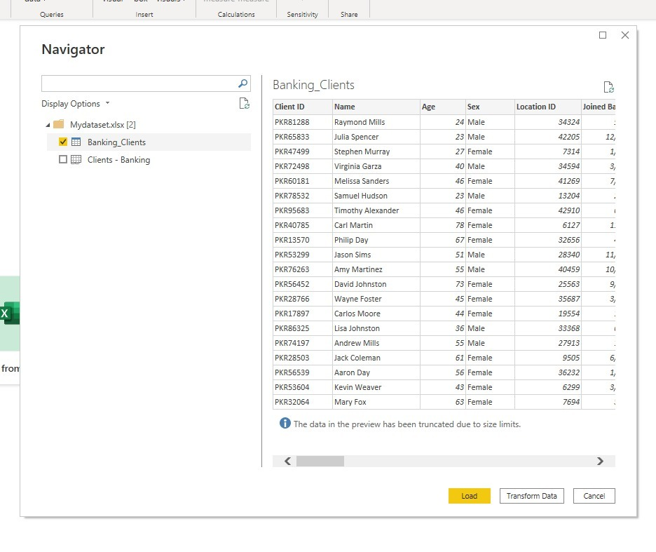

1. After clicking on Transform data then remove all unwanted unnecessary columns so that we can perform the operation on the column which we want to visualize them in a dashboard or a report generation.
2. After deleting the column the data will be remained like below one.

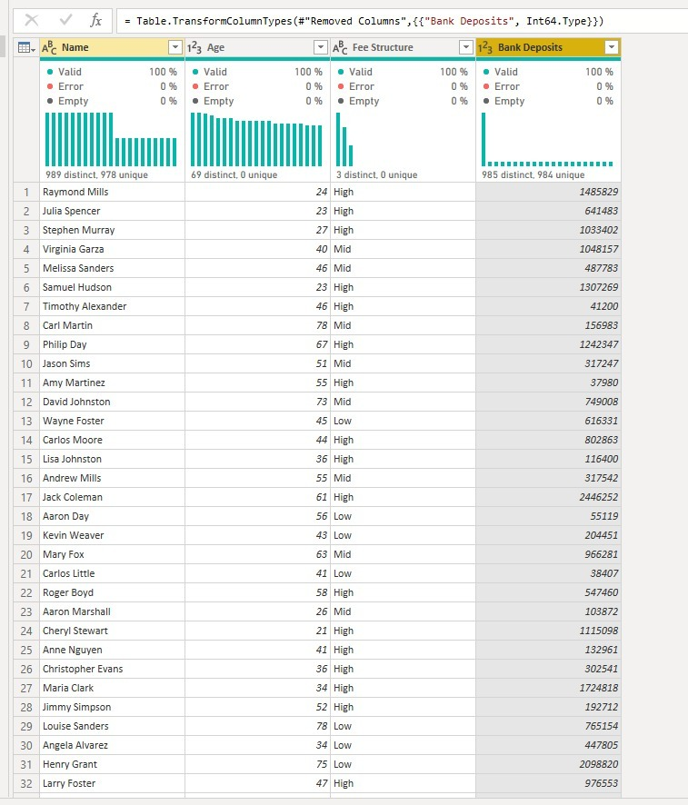

1. Now, navigate to the ADD Column there you will find an option called add an conditional column now, click on that and apply condition on that column so that you can filter your data.

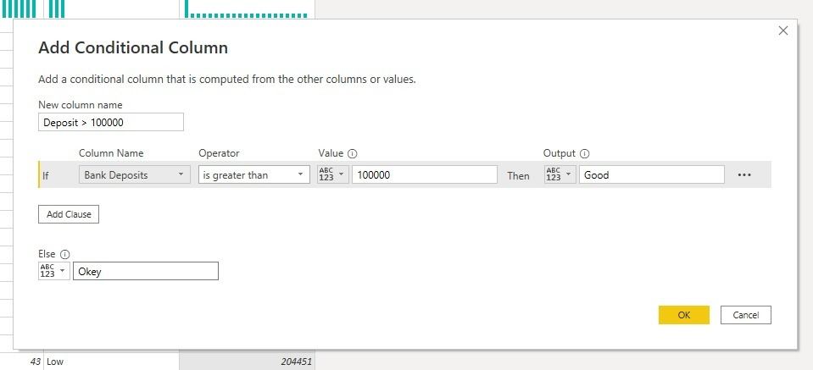

1. After applying the conditions on the column now, can see the change effected on the dataset the below pic is the final dataset which I modified according the requirements of the given Aim.

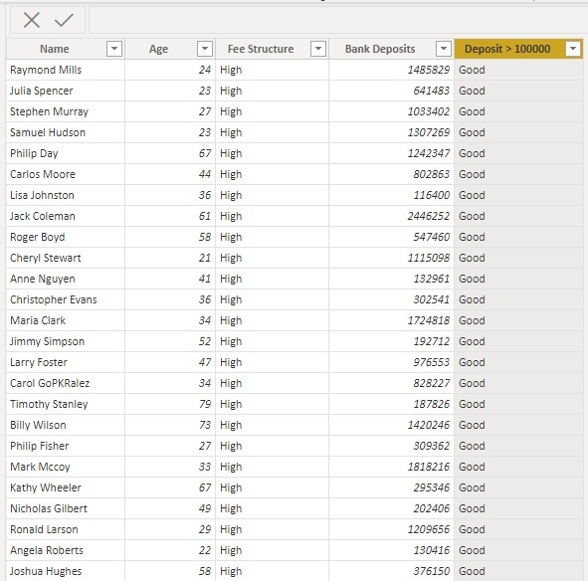

1. Now, we have to visualize this modified dataset in the dashboard.

**Output :**

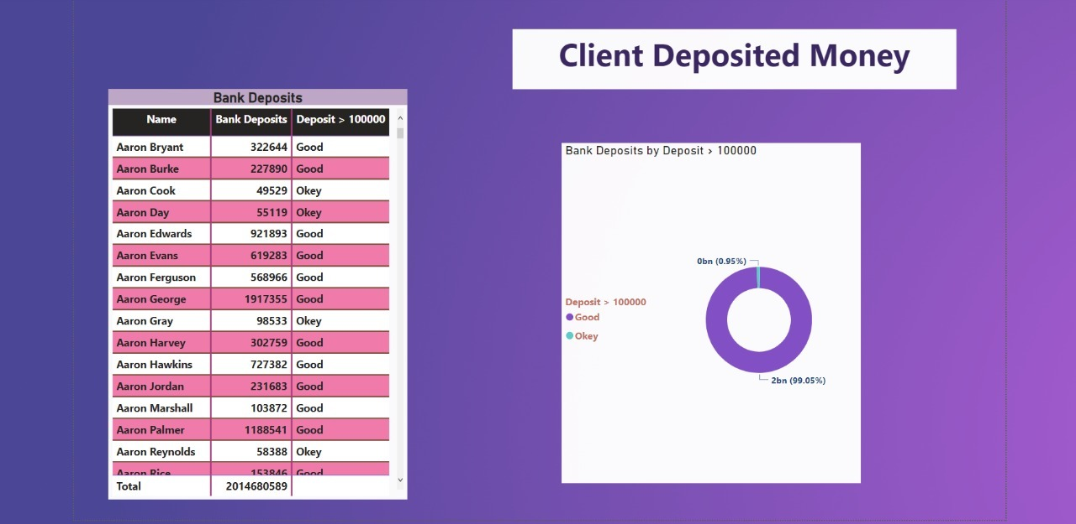

# **Task – 7**

**Aim :**  Create a small dataset and perform a group by operation on dataset

And perform visualize them on dashboard.

**Procedure :**

1. Open the power bi and click on the get data option and then click on the text /csv format then upload the csv file and click on transform data to perform group by operation.

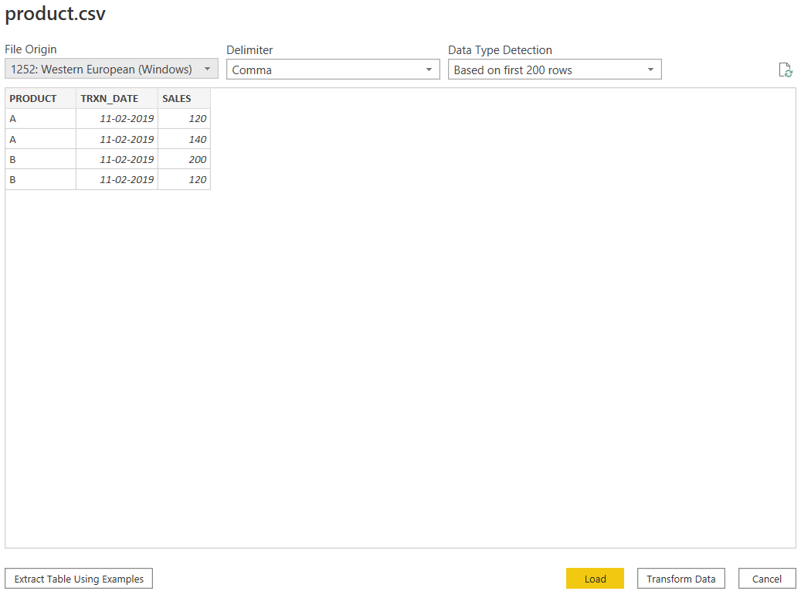

1. When you click on transform data then you will enter into an new window called power bi query editor which is also known as kitchen of the power bi.

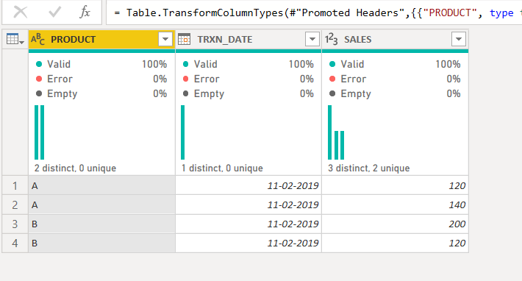

1. Now , navigate to the Transform there you can see the group by option. Click on the option.
2. Group by operation means grouping the similar data based on given aggregate operation.

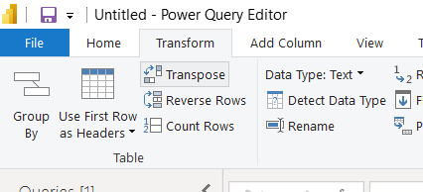

1. After clicking on group by option now select the product column i.e data will be grouped by based as product and performs aggregate sum operation also.

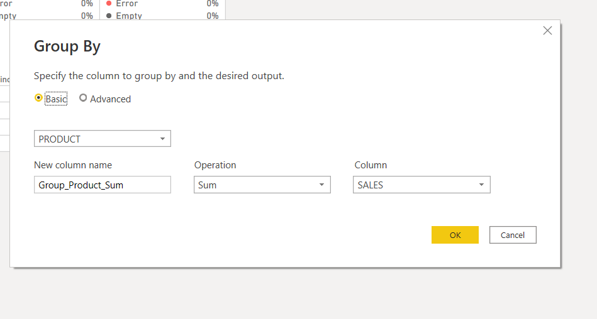

1. This is the final result after performing the group by operation .

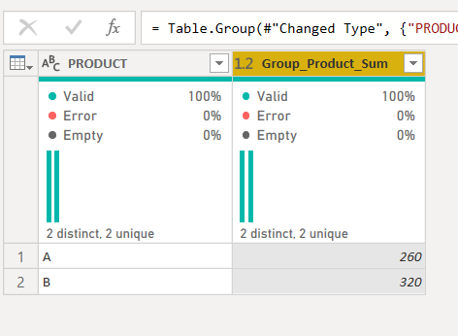

**Output :**

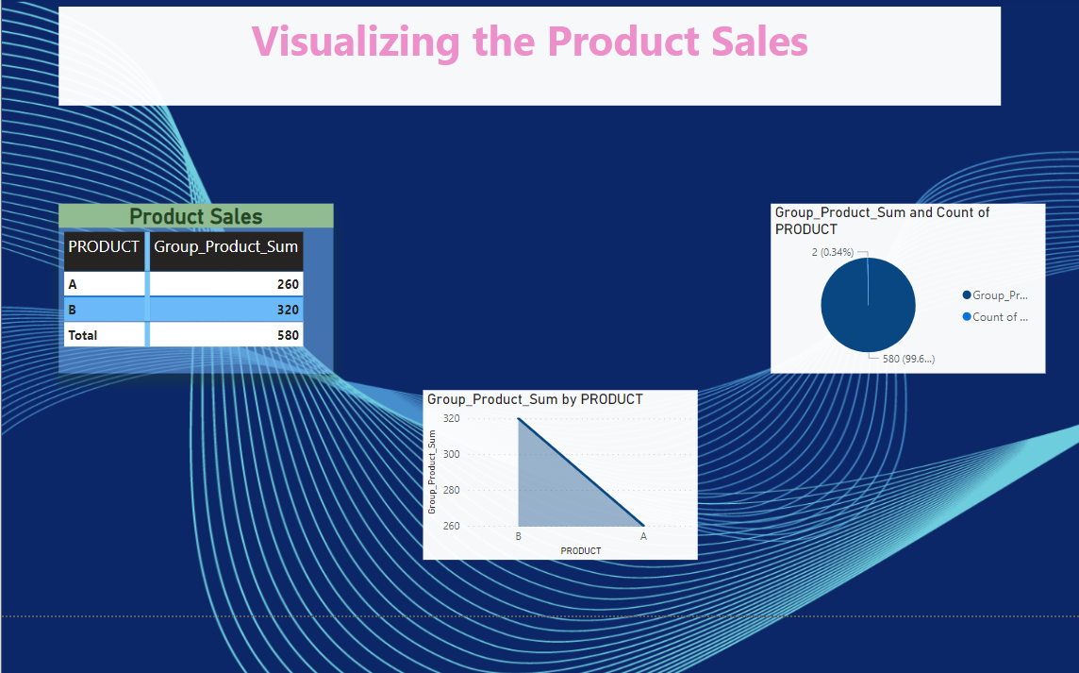

**Aim :** Perform group By operations on Banking dataset and visualize them.

**Procedure :**

1. First Load the dataset into the Power bi and click on transform to remove the unwanted attributes or columns in dataset.



1. After clicking the transform data then you will be entered in to an power bi query editor where you can fully analyze the data now we have to remove the unwanted or unnecessary attributes which are not releated to the present doing Task.
2. After deleting or removing all unwanted attributes in the dataset then the final modified dataset will be like below one.

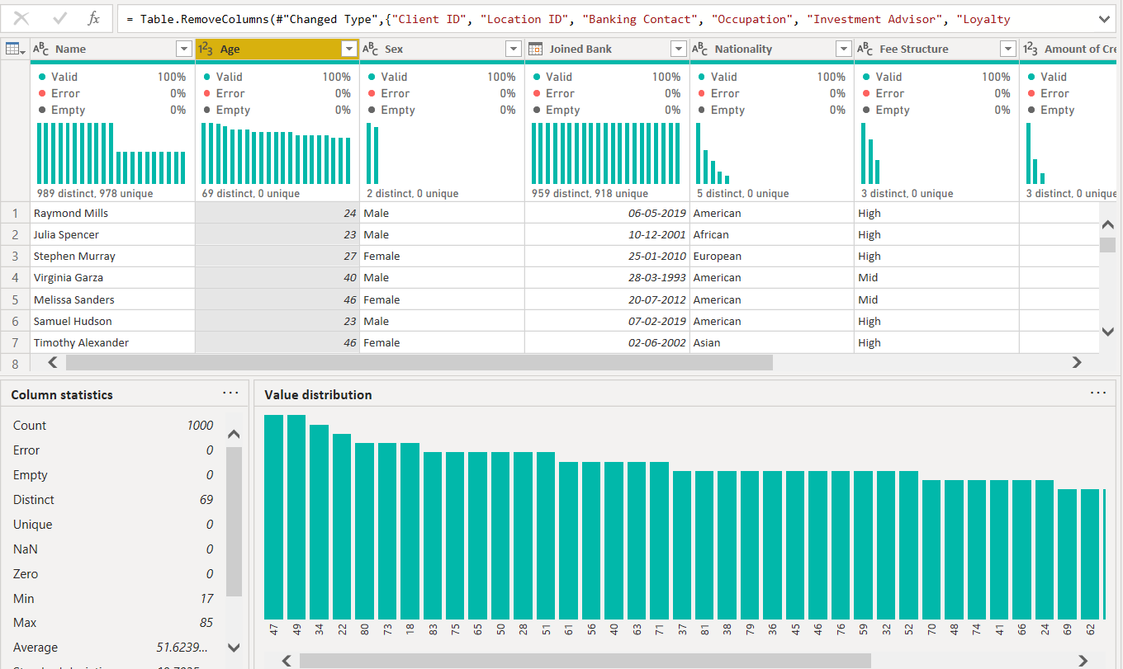

1. Navigate to the Transform there you can find the group by operation click on the option then fill the details in the pop up box and then click ok.

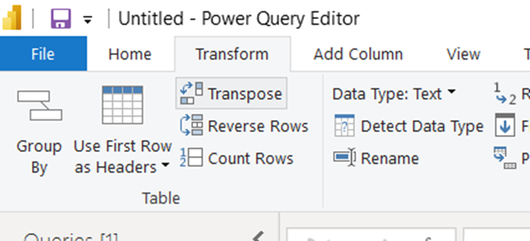

1. Now, do group the sex attribute and apply the aggregate sum operation on bank deposits make sure that attribute should contain labelled data.

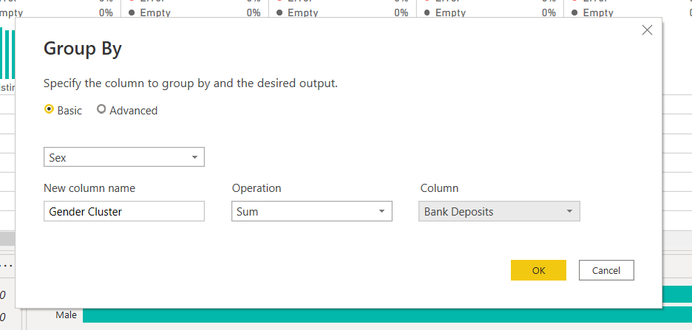

1. The final data will be like below pic after grouping the sex attribute.

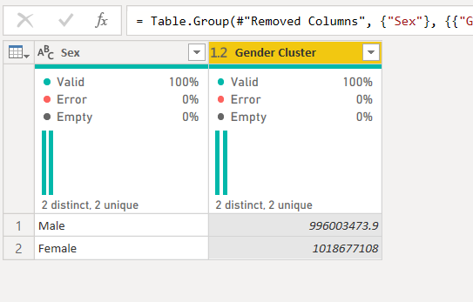

**Output :**

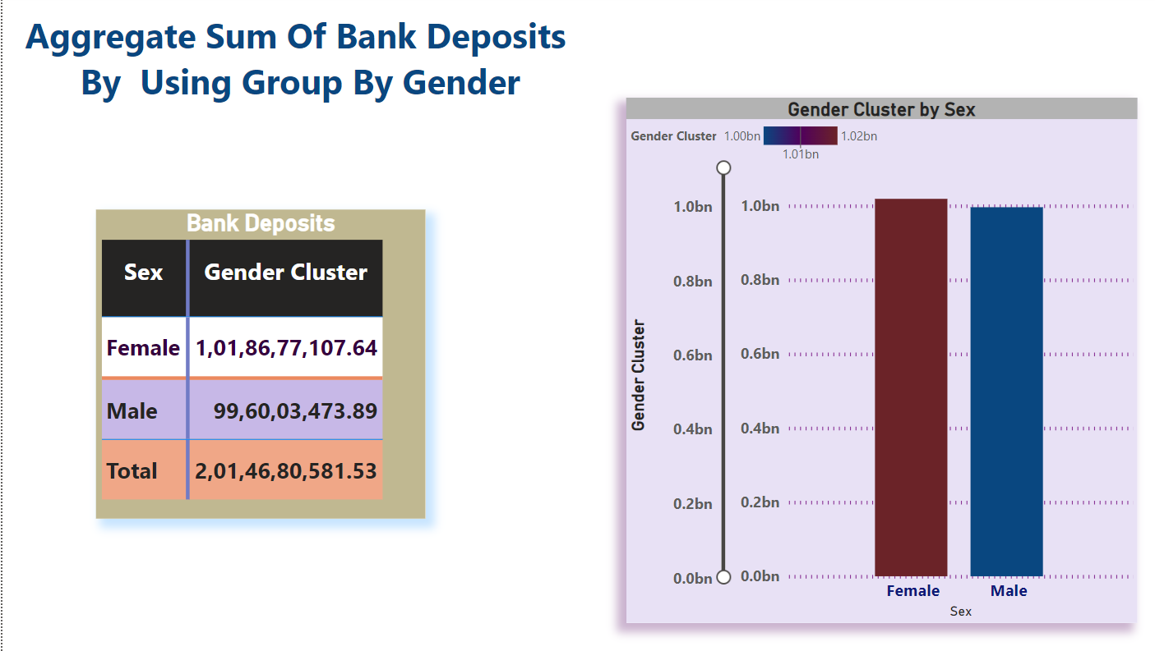

**Aim :** Apply joins and merging queries topic in any dataset and

Visualize it.

**Procedure :**

1. To apply joins we shold have atleast 2 Tables or relations.
2. First, we have load the both relations or tables into an power bi.
3. After click on Get Data select the excel option to load the fisrt table into an power bi after then click on Load option.

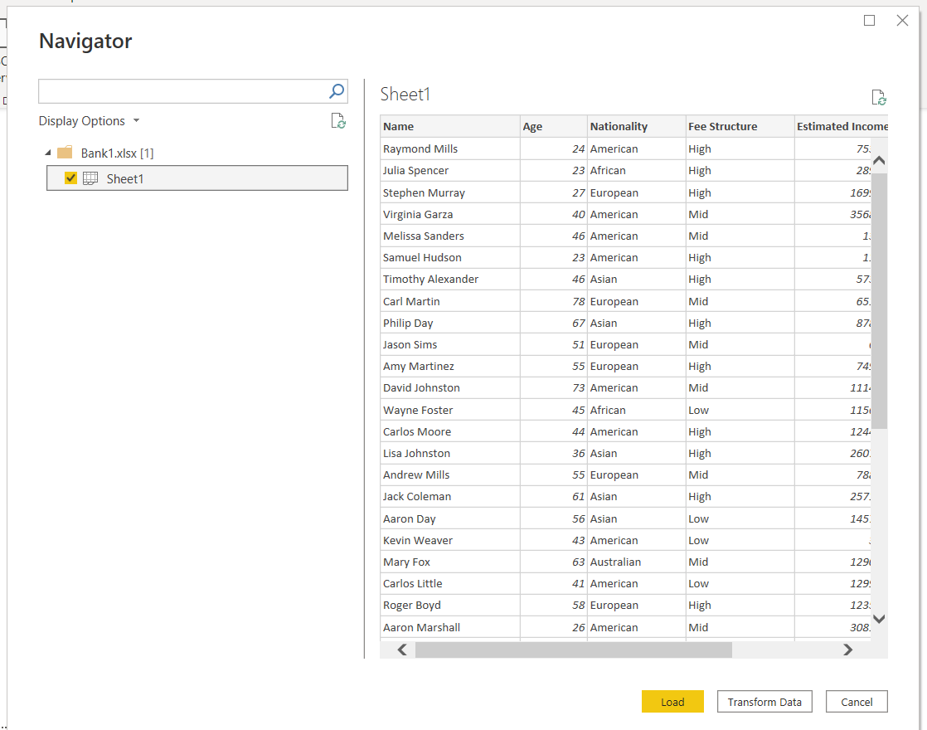

1. After click on Get Data select the excel option to load the Second table into an power bi after then click on Load option.
2. The next step is to enter into an power bi query editor where we can perform joins and merging queries at a same time.
3. Navigate to the home tab where you can find the merging queries option now click on that option.

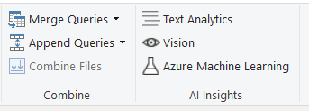

1. Then you will get an pop up window fill the required details to perform the joins operation.

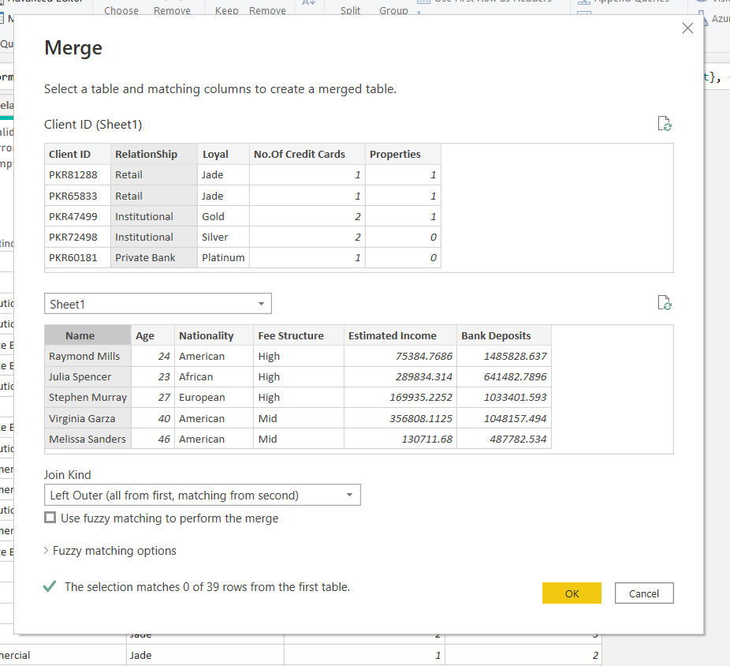

1. After performing the merging operation now save the changes in query editor.
2. The last and final step is visualize them in a interactive dashboard.

**Output :**

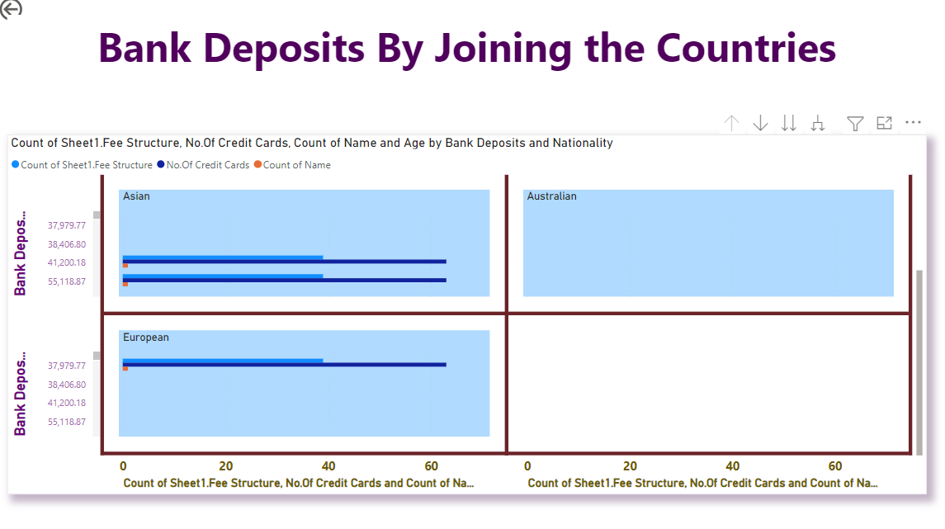

# **Task – 8**

**Aim :**  Explore the different types of charts and graphs in the visualizing

The data.

**Description :**

* Data from a table can be presented in many ways and they are
  + Charts
  + Graphs

|  |  |  |  |
| --- | --- | --- | --- |
| **S.no** | **Chart Name** | **Parameters** | **Significance** |
| 1 | Dot Plot | X : 1  Y : min 1 | It is one of the way to visualize the similarity between 2 parameters by using an similarity matrix. |
| 2 | Bar Chart | X : 1  Y : 1 | This is a very simple chart to understand the status of work and also Compares the 2 variables like day and sales. |
| 3 | Floating Bar Chart | X : Category Value  Y : 1 | They visually show in a very effective at-a-glance way, the overall time line of the project, the current status & progress (or lack thereof) along with the assignment at considerable details. With this custom visual, |
| 4 | Pixelated Bar Chart | X : 1 or more  Y : 1 | The basic idea of a pixel bar chart is to present the data values directly instead of aggregating them into a few data values. The approach is to represent each data item (e.g. a customer) by a single pixel in the bar chart. |
| 5 | Histogram | X : 1 | By combining a histogram chart with points that show the actual data for each range. ​Easily track where data clusters (points) across your data distribution (bars) to identify patterns, trends, and areas of opportunity. |
| 6 | Pie Chart | variables | It displays the status percentage of the work or project in various categories |
| 7 | Tree Map Chart | Any number of variables | A treemap chart provides a hierarchical view of your data and makes it easy to spot patterns, such as which items are a store's best sellers. The tree branches are represented by rectangles and each sub-branch is shown as a smaller rectangle. |
| 8 | Bubble Chart | Categorical variables | Bubble Chart with categorical Data on X and Y axis will enable the user to visualise categorical data such as date, category or any text field on X-axis and Y-axis simultaneously. This chart will help you to visualise data in three dimensions on X axis, Y axis and size dimension. |

**Result :** Sucessfully completed the Aim .

# **Task – 9**

**Aim :**  Installation of the tableau application.

**Procedure :**

1. Open any interactive browser and type the url i.e; <https://public.tableau.com> .
2. After visting to that site then navigate to the create dropdown in the navigation bar and there select the “download tableau public version.”

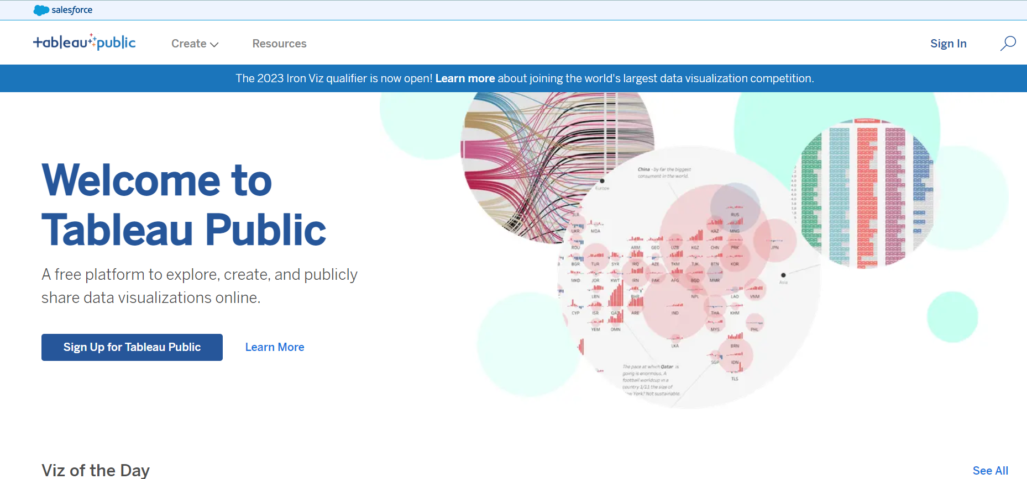

1. After clicking on the option it will ask the registration form details.
2. Fill the form with your details and then click on the download.

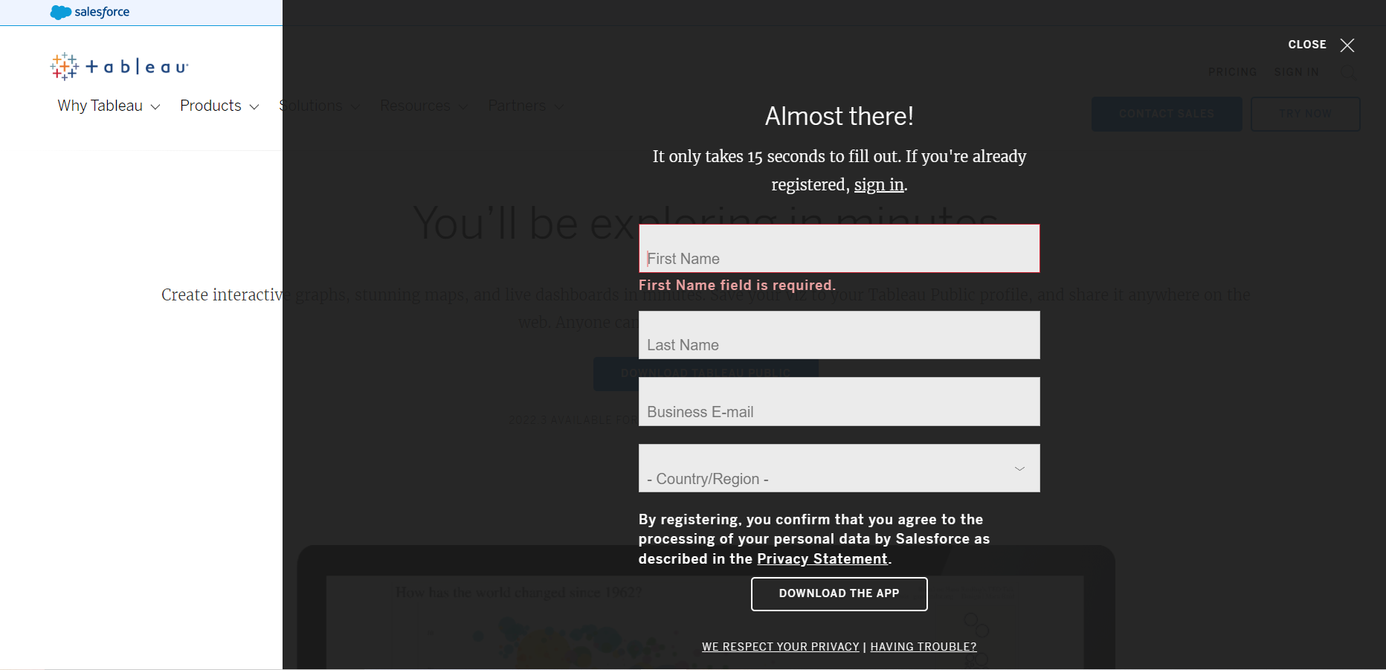

1. After clicking on the download option then you can the application on your system.
2. To save the work on the tableau application you have to create a account in the https://public.tableau.com .

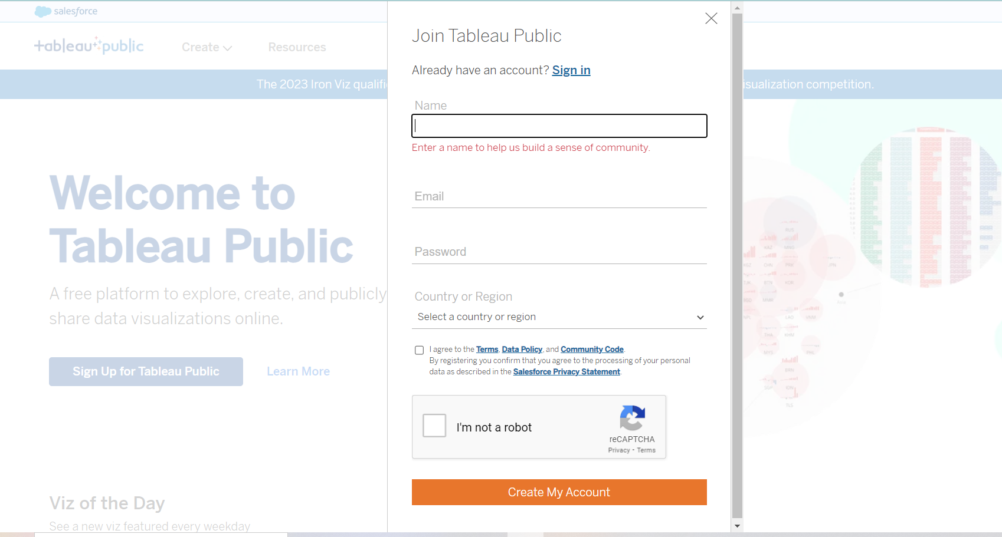

1. The account you have created is also called a tableau viz account.
2. Where all your work will be saved to this account.
3. And it’s is in public state by default.

**Result :** successfully installed the application.

# **Task – 10**

**Aim :** implement pie chart, area chart, bubble chart on real time data.

**Procedure :**

1. Open the tableau application and then load the real time dataset on to the tableau.

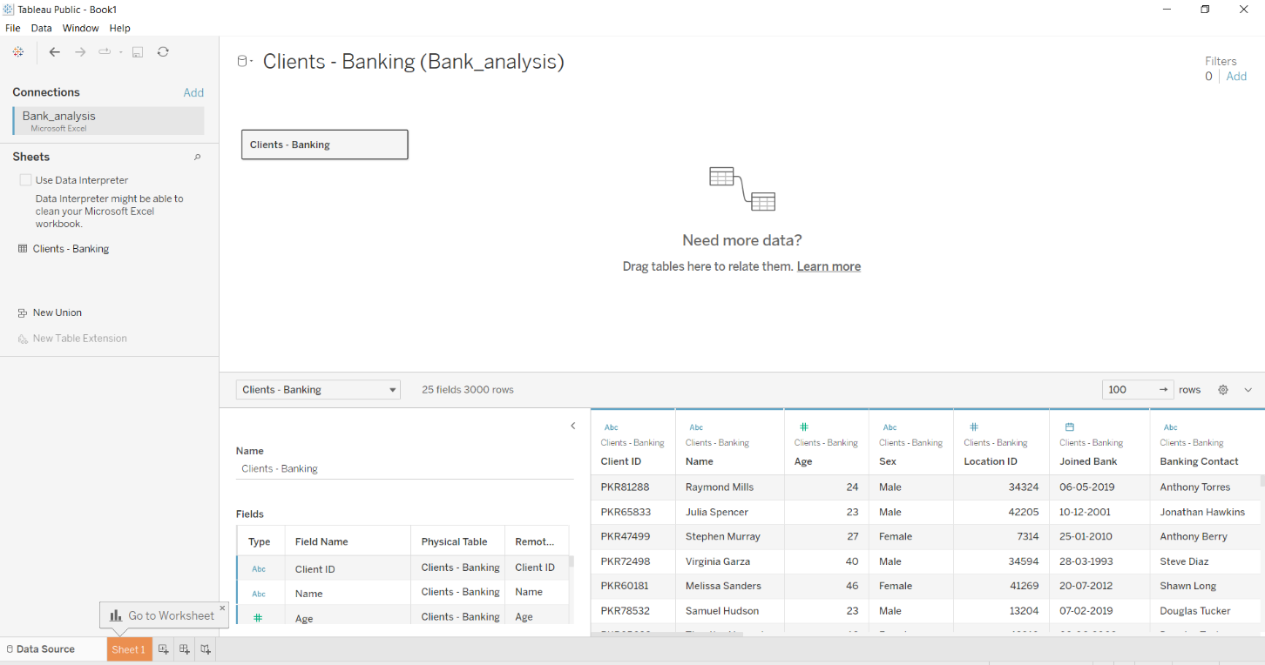

1. Now create a Pie Chart with an connection between banking relation ship, fee structure , nationality.
2. And create a Area chart with year and saving account attribute and make sure that it is having discreate data on those attributes.
3. Last one create a packed bubble chart with occupation and risk weighting analysis attributes.
4. **Pie chart :**

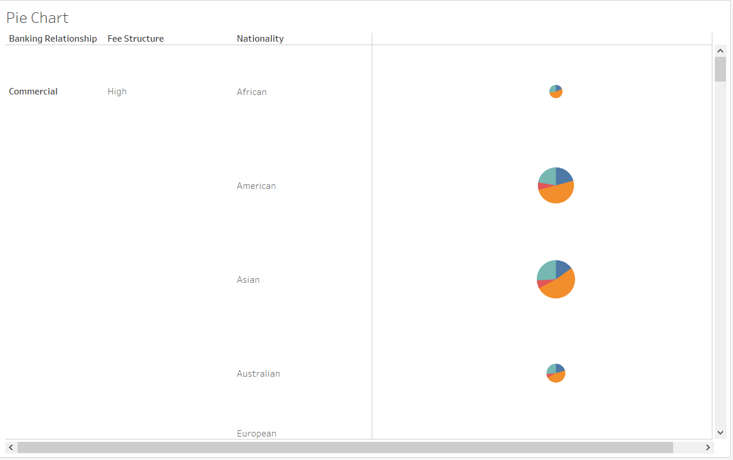

1. **Area Chart :**

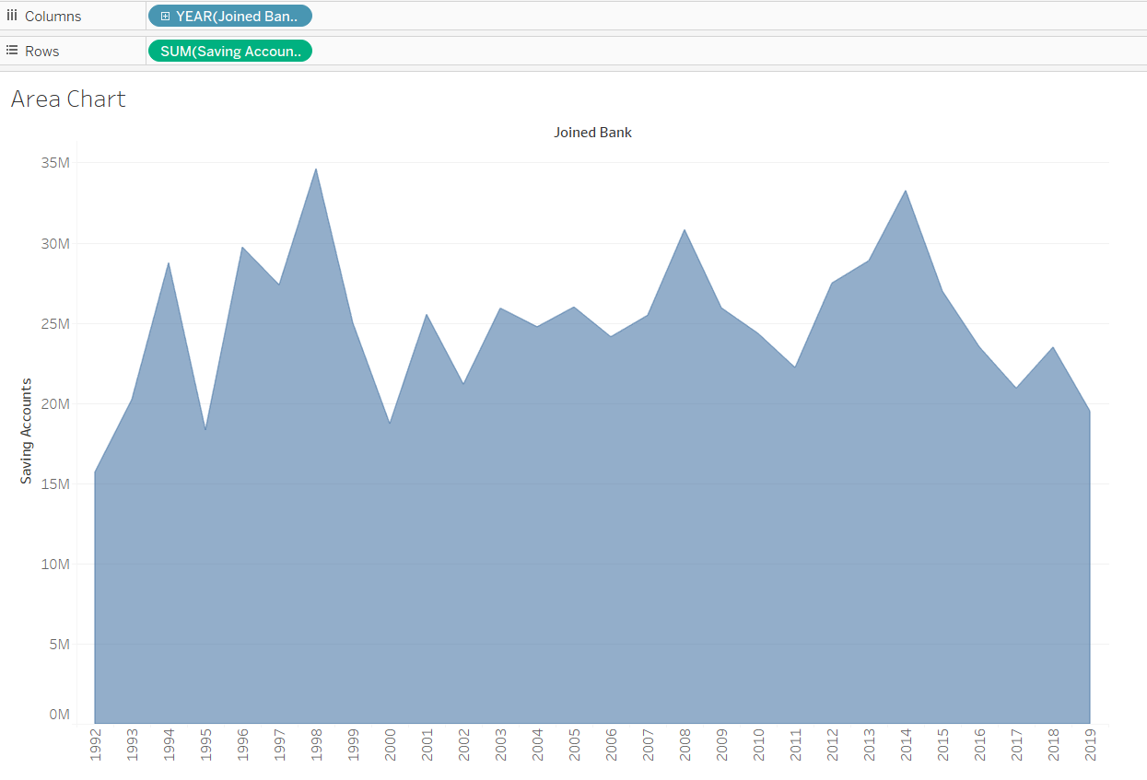

1. **Packed Bubble chart :**

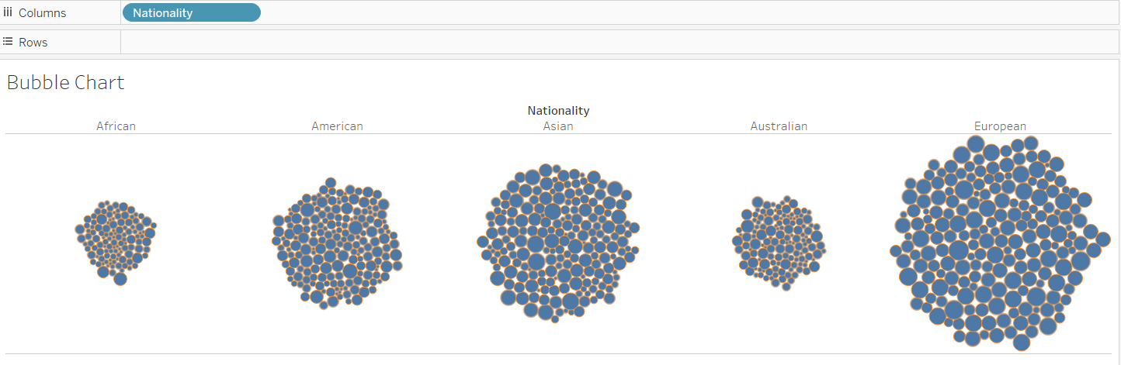

**Output :**

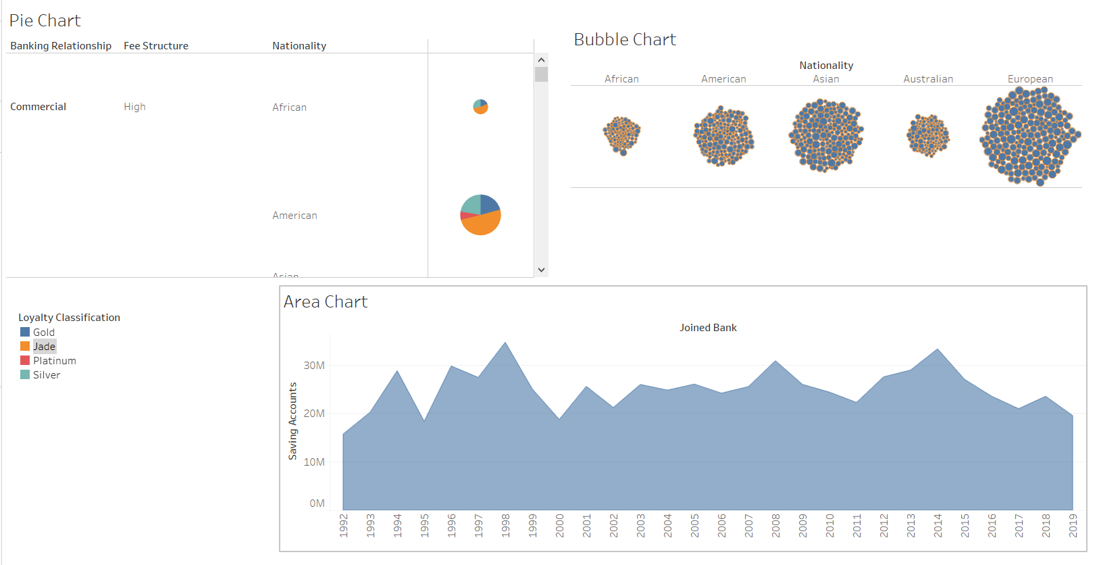

**Result :** Sucessfully completed the task.

# **Task – 11**

**Aim :** Explore the features of the tableau application or software.

**Features :**

1. **Tableau DashBoard :**

Tableau Dashboards provide a wholesome view of your data by the means of visualizations, visual objects, text, etc. Dashboards are very informative as they can present data in the form of stories, enable the addition of multiple views and objects, provide a variety of layouts and formats, enable the users to deploy suitable filters. You even have the option to copy a dashboard or its specific elements from one workbook to another easily.

1. **Collaboration Sharing :**

Tableau provides convenient options to collaborate with other users and instantly share data in the form of visualizations, sheets, dashboards, etc. in real-time. It allows you to **securely share data** from various data sources such as on-premise, on-cloud, hybrid, etc. Instant and easy collaboration and data sharing help in getting quick reviews or feedback on the data leading to a better overall analysis of it.

1. **Live & In – Memory Data :**

Tableau ensures connectivity to both live data sources or data extraction from external data sources as in-memory data. This gives the user the flexibility to use data from more than one type of data source without any restrictions. You can use data directly from the data source by establishing live data connections or keep that data in-memory by extracting data from a data source as per their requirement. Tableau provides additional features to support data connectivity such as automatic extract refreshes, notifying the user upon a live connection fail, etc.

1. **Data Sources in Tableau :**

Tableau offers a myriad of data source options you can connect to and fetch data from. Data sources ranging from on-premise files, spreadsheets, relational databases, non-relational databases, data warehouses, big data, to on-cloud data are all available on Tableau. One can easily establish a secure connection to any of the data sources from Tableau and use that data along with data from other sources to create a combinatorial view of data in the form of visualizations.

1. **Maps :**

Yet another important feature of Tableau is the map. Tableau has a lot of pre-installed information on maps such as cities, postal codes, administrative boundaries, etc. This makes the maps created on Tableau very detailed and informative. You can add different layers of geology on the map as per your requirements and **create informative maps** in Tableau with your data. The different kinds of maps available in Tableau are [***Heat map***](https://data-flair.training/blogs/tableau-heat-map/), Flow map, Choropleth maps, Point distribution map, etc.

1. **Robust Security :**

Tableau takes special care of data and user security. It has a fool-proof security system based on authentication and permission systems for data connections and user access. Tableau also gives you the freedom to integrate with other security protocols such as Active Directory, Kerberos, etc. An important point to note here is that Tableau practices row-level filtering which helps in keeping the data secure.

**Result :** Sucessfully gained knowledge towards the features of the tableau.

# **Task – 12**

**Aim :** Implementing data visualization using R

1. Find the data distributions using box and scatter plot.

2. Find the outliers using plot.

3. Plot the histogram, bar chart and pie chart on sample data

**R – Program :**

install.packages("readxl")

library("readxl")

# ggplot installation

install.packages("ggplot2")

library(ggplot2)

install.packages("dplyr")

library(dplyr)

getwd()

setwd(choose.dir())

getwd()

re = read_excel("Bank_analysis.xlsx")

re = data.frame(re)

re

class(re)

# Box Plot

ggplot(re, aes(x = Bank.Deposits, y = 1)) + geom_boxplot()

# Scatter Plot

ggplot(re, aes(x = Name, y = Bank.Loans)) + geom_point()

# Outliers in Box Plot

boxplot(re$Bank.Deposits,plot=TRUE)$out

# histogram

ggplot(data = re) + geom_histogram(aes(x = re$Saving.Accounts))

# Bar Chart

barplot(re$Estimated.Income, names.arg = re$Name, xlab ="Names",

ylab ="Income",

main ="Bar Chart")

# Pie Chart

pie(re$Credit.Card.Balance, re$Nationality,

main = "PIE chart", col = rainbow(5))

**Outputs :**

* **Box Plot :**

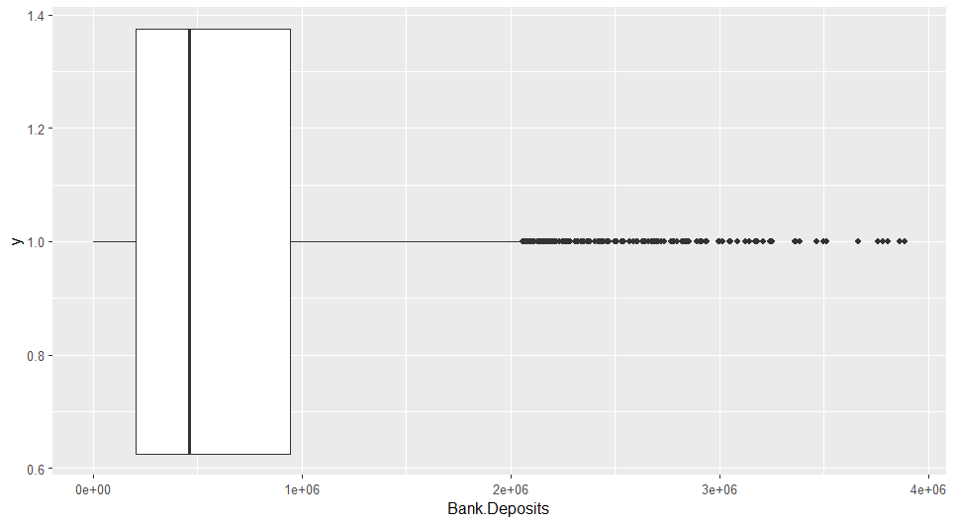

* **Scatter Plot :**

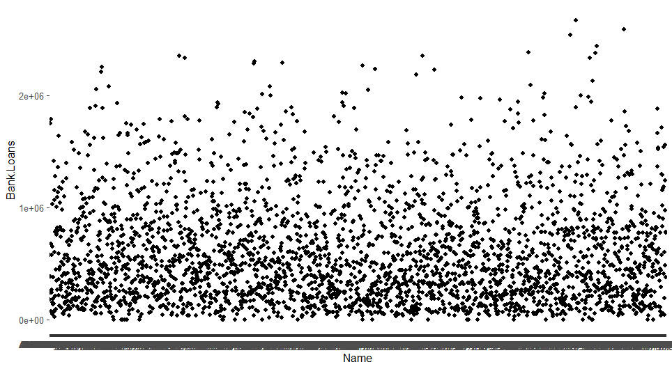

* **Outliers in Boxplot :**

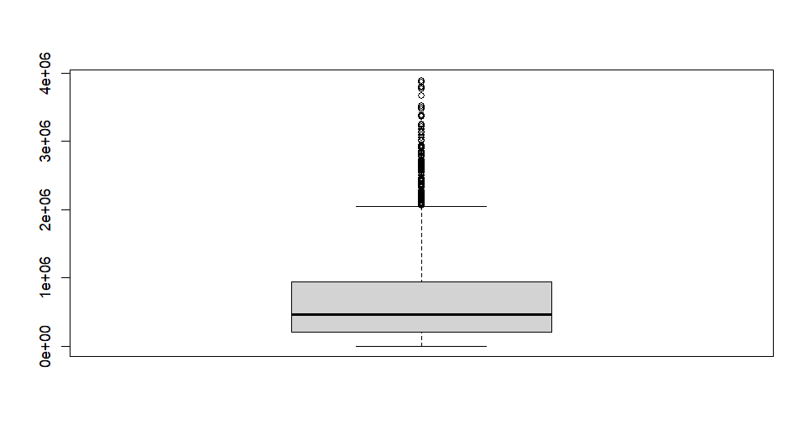

* **Histogram :**

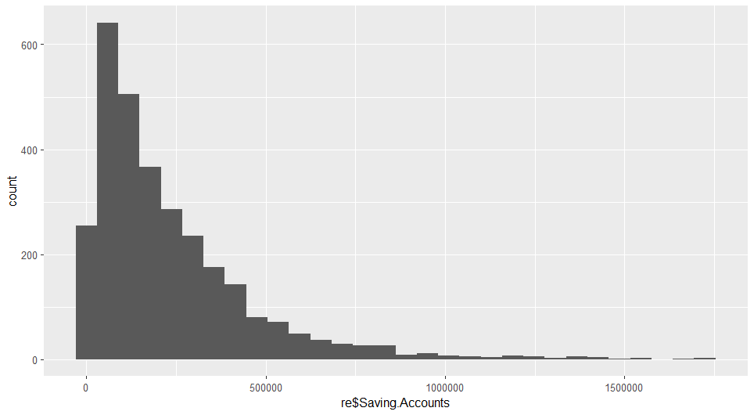

* **Bar Chart :**

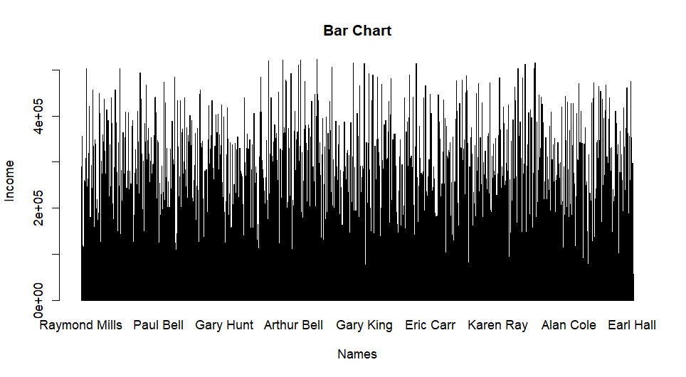

* **Pie Chart :**

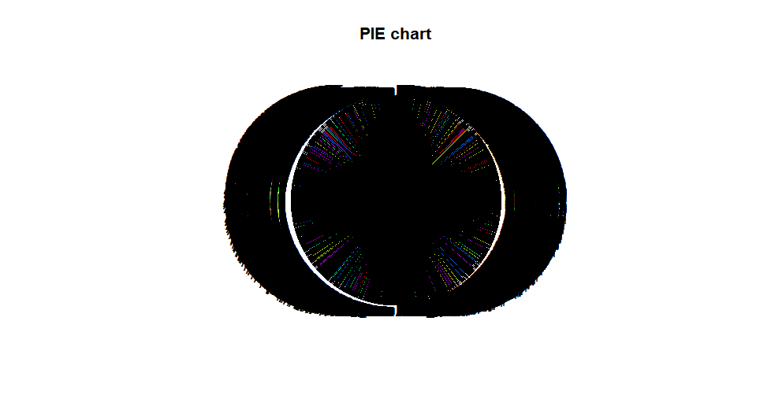

**Result :** Sucessfully Executed the Program.

# **Task – 13**

**Aim :** Implementing basic operations in Tableau to get accustomed to its interface and Emphasizing the Results and Map View

[1] Tableau Workspace, Connecting to a Data Source, Creating a view and Refining the view

[2] Adding Filters to the view, Adding Colors to the view and Key Findings

[3] Building a Map View, Getting into details and Identifying the Key Points.

**Procedure :**

**Connecting to the Data Source :**

1. Open the tableau software and click on the “ To a File Microsoft Excel “ and then click on connect option.

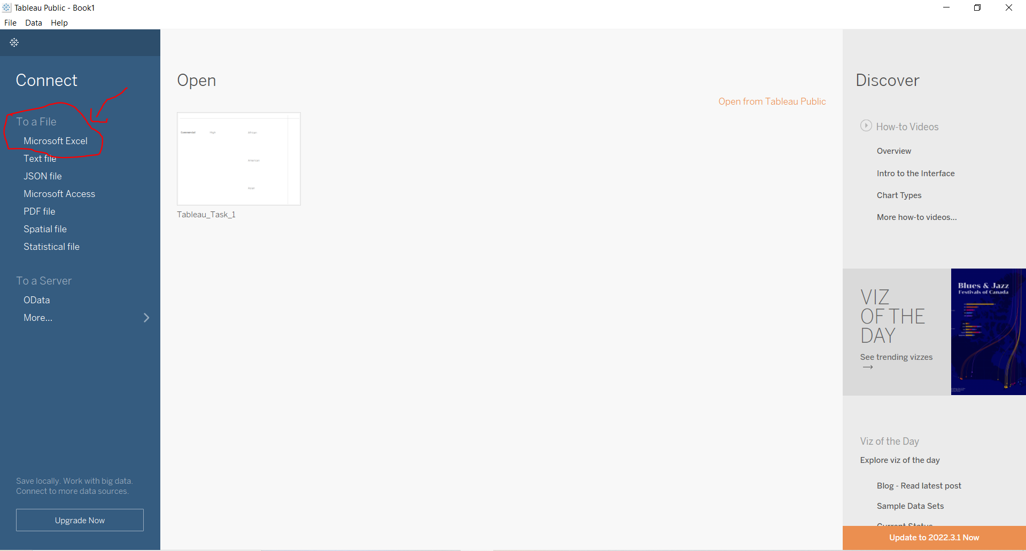

1. Then it will load the data source into the tableau.

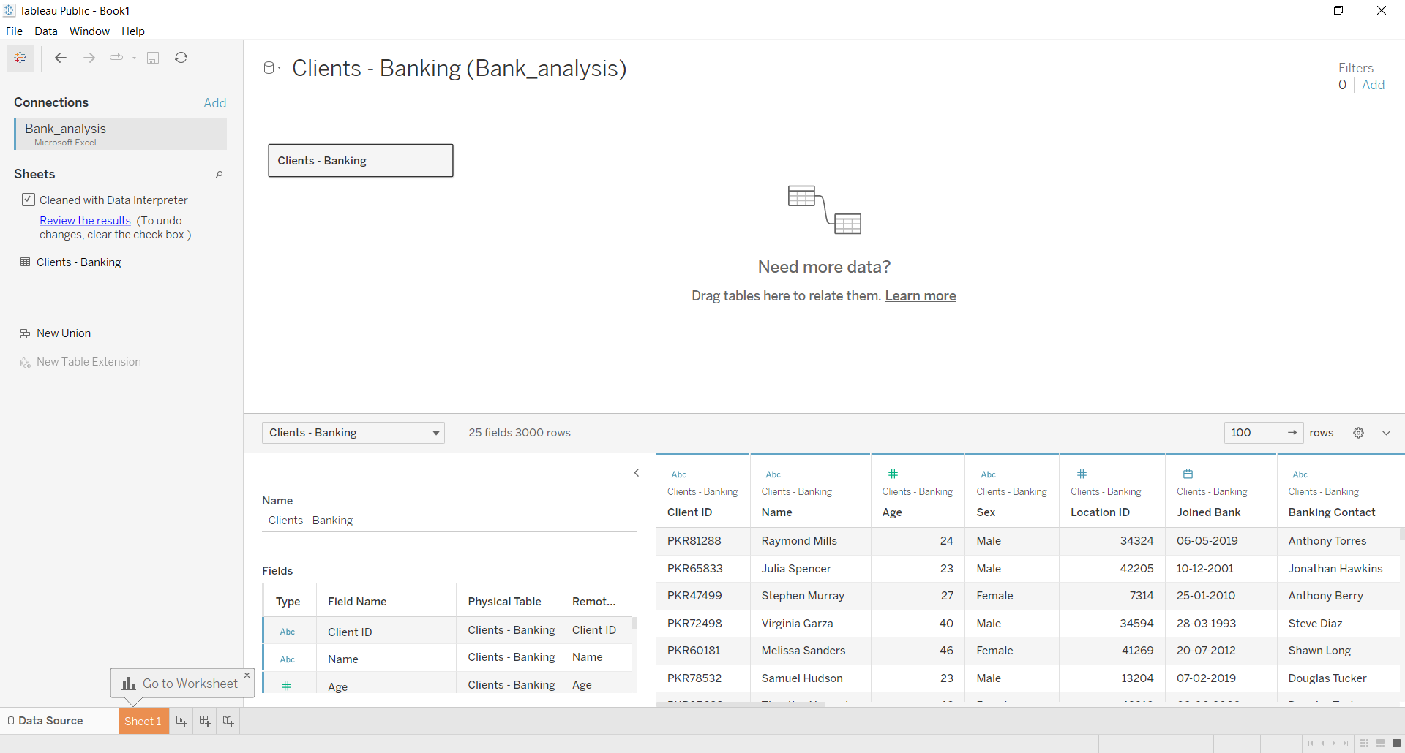

1. Manually Created a view using the existed data in the data source. And you can use the marks card to make changes in the view for better understanding
2. Here is a small pic of marks which helps in understanding the view while hovering on the point or for understanding purpose.

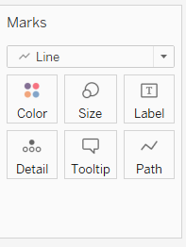

1. In this view we can see the bank customers pointing to their how much they have taken the loans using the line chart.
2. And also added colors , filters to the row and column shelf.

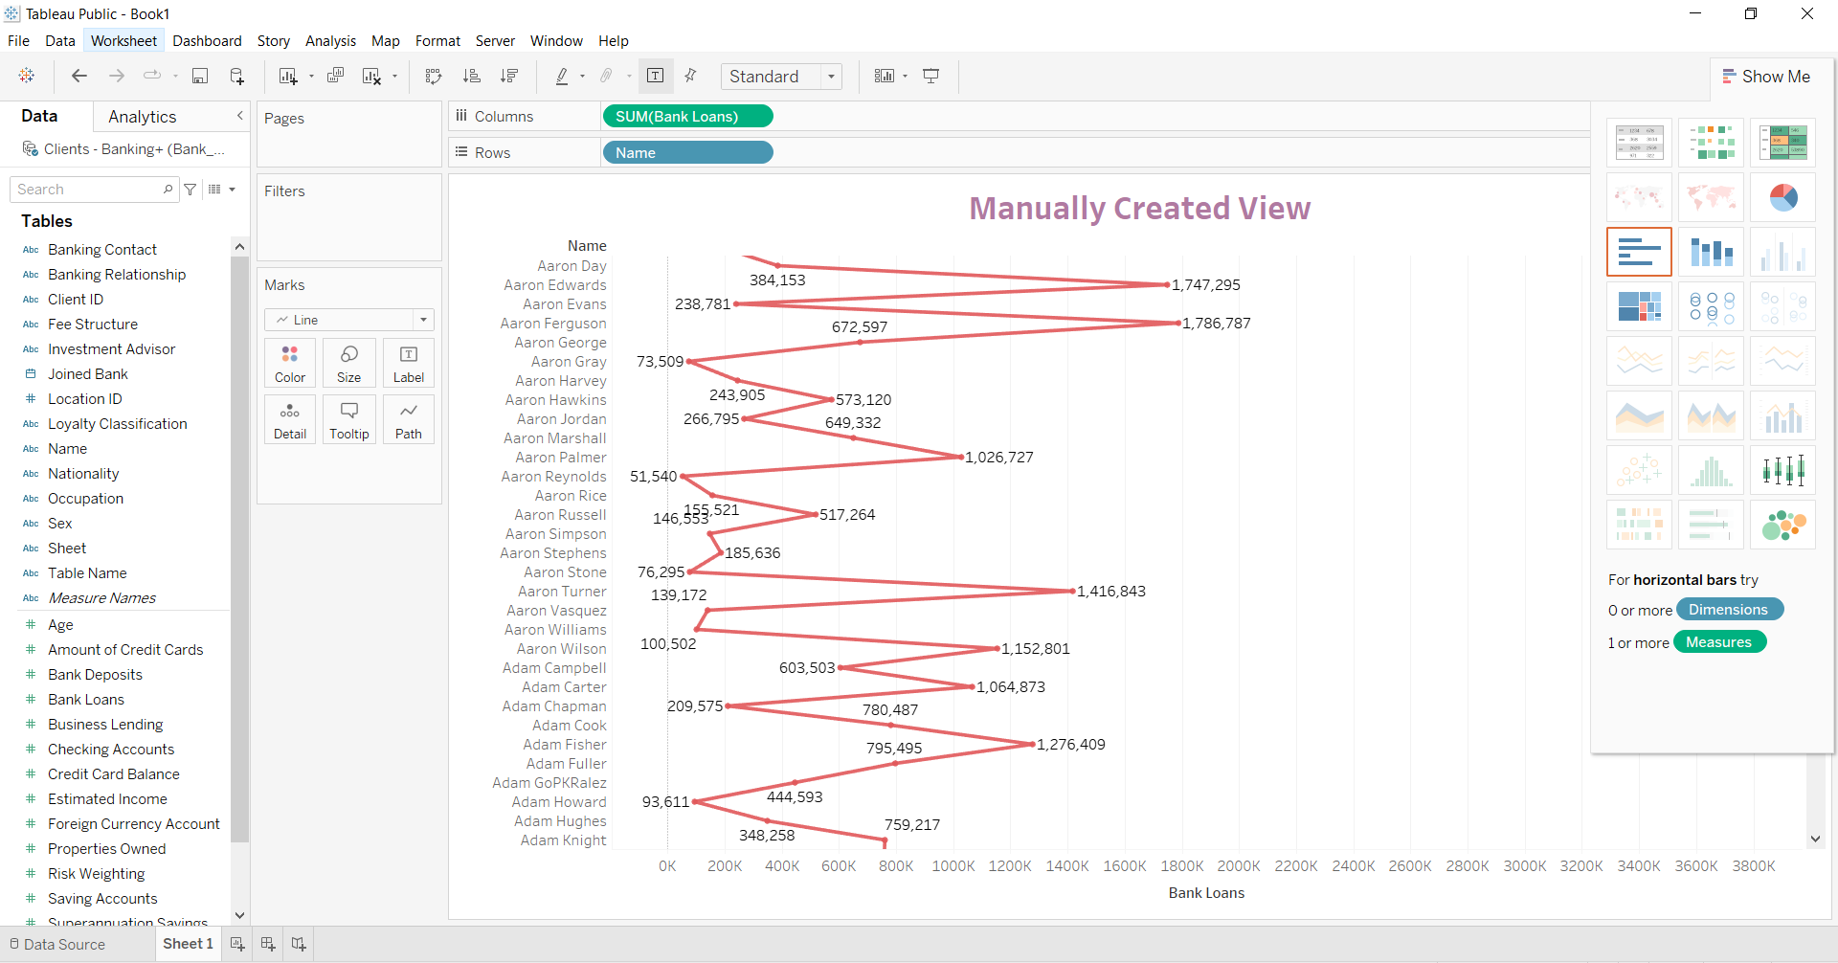

1. Filter the data present in column by right clicking and choosing the filter option.

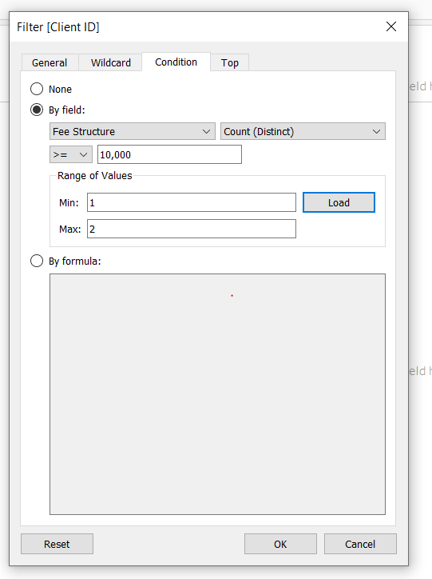

**Output :**

